Short term plan: term 3

Unit: 5 Reading for pleasure |  | Lesson 49
Teacher name:

Date:
Grade: 8 |  | Number present: | absent:
Lesson title | Story elements
Learning objectives | 8.2.1.1 understand with little or no support the main points in extended talk on a wide range of general and curricular topics;  8.3.7.1 use appropriate subject-specific vocabulary and syntax to talk about a range of general topics, and some curricular topics
Lesson objectives | Learners will be able to:  - learn vocabulary for the elements of a story.  - listen to people talking about books.  - talk about a book I've read recently.
Value links | "Law and Order"  Know the basics of the legal system and human rights
Plan

Stages / Time | Teachers actions | Students actions | Assessment criteria | Resources
Beginning of the lesson  5 min.  Middle of the lesson  Presentation part.  35 min | Organization moment :  1.Greeting.  Ask about the weather.  Warming up  The teacher sets the lesson objectives, letting students know what to anticipate from the lesson.  Lead – In    Ex:1 P57  Put students into pairs to match the definitions with the elements of a story.  Play the recording for students to listen, check their answers and repeat the words and phrases.  Pay particular attention to the pronunciation of villain /'vilən/. You could explain that a villain may also be called the bad guy or the baddie /badiv. . Point out that these words can be used to talk about both books and films. | Students of the class are listed.  Students' attention is drawn to the lesson.  Students say different words from the picture  Learners answer the questions  Learners match the story elements in the box with the definitions. Then listen, check and repeat.  ANSWERS  2 main character(s)  3 hero  4 suspense  5 villain  6 mystery  7 action  8 setting | The teacher to assess learners for their ability.  “Good job!  Well done!”  Formative Assessment    Good job!  Descriptor:  - match the story elements  - listen, check their answers  Total: 2 point | Pictures
 | Ex: 2 P: 57  Refer students to the description of The Lion, the Witch and the Wardrobe.  Ask students to read the description and then put students into pairs to identify the different elements of a story contained within it.  Check answers.  Differentiation: «Verbal support» method is used to help Ss use new words in the sentences.  Ex: 3 P: 57  Tell students they are going to listen to two people talking about a book they've read recently.  Play the recording for students to note down which four elements of a story are mentioned.  Check answers  Ex: 4 P: 57  Give students time to think of a book they've read and make some notes on it. | Learners identify the story elements in the description below  ANSWERS  plot - Aslan is trying to win back his kingdom  setting a fantasy world  main characters - four children  hero - Aslan, an enormous lion  villain the White Witch  suspense the White Witch almost kills Aslan  mystery - Aslan, by some incredible magic, comes back to life  Learners listen to two people talking about a book they’ve read. Which four story elements do they talk about?  ANSWERS  setting, plot, main characters, action  Learners think of a book you’ve read recently. Make notes on some of the story elements from Exercise1  ANSWERS  Students own answer | Descriptor:  - read the description  - identify the story elements  Total: 2 point  Descriptor:  - listen to two people talking  -answer the question  Total: 2 point  Descriptor:  - make notes  - read recently  Total: 3 point  -Make CCQ questions Yes / No |   Card  Worksheet  Students book
End of the lesson  5 min | FEEDBACK  Learners provide feedback on what they have learned at the lesson.  Ex: P:  Home task:  Write the days | Ss evaluate each other and encourage classmate with phrases like:  Well done! Brilliant! Good job! I like it! |  | Poster Success  

Short term plan: term 3

Unit 5 Reading for pleasure |  | Lesson 50
Teacher name:

Date:
Grade: 8 |  | Number present: | absent:
Lesson title | Reading A plot summary
Learning objectives | 8.2.1.1 understand with little or no support the main points in extended talk on a wide range of general and curricular topics  8.3.3.1 give an opinion at discourse level on a wide range of general and curricular topics  8.4.2.1 understand specific information and detail in texts on a growing range of general and curricular topics, including some extended texts
Lesson objectives | Learners will be able to:  - listen to people talking about books.  - talk about a book I've read recently.
Value links | "Law and Order"  Observance of norms and rules of order and justice understand the need
Plan

Stages / Time | Teachers actions | Students actions | Assessment criteria | Resources
Beginning of the lesson  5 min  Middle of the lesson  Presentation part.  35 min | Organization moment :  1.Greeting.  Ask about the weather.  The teacher sets the lesson objectives, letting students know what to anticipate from the lesson.  Warming up  Ask a few pupils to stand up and stand in a row. Ask the rest of the class questions to revise the ordinals.  Lead – In    Ex:1 P:58  Refer students to the picture and then put students into pairs to answer the questions. You can pair stronger students with weaker students to discuss their ideas.  Do not confirm or reject students' ideas at this point. Students will check their ideas by reading the text in Exercise 2. | Students of the class are listed.  Students' attention is drawn to the lesson.  Determines the topic and purpose of the lesson  Students say different words from the picture  Answer the question.  Pupils work with a partner. Look at the picture and answer the questions  ANSWERS  Students own answer | The teacher to assess learners for their ability.  “Good job!  Well done!”  Formative Assessment    Good job!  Descriptor:  - work with a partner  - look at the picture  - answer the question.  Total: 2 point | Pictures
 | Ex: 2 P: 58  Students can then discuss their response to the end of the story, saying what they think happens and why. Some students will find this form of speculation easier than others. Encourage stronger students to go into greater detail than weaker students.  Refer students to the information in the FACT! box. Ask students what they think a world without books would be like.  Ex: 3 P:58  Refer students to the events a-g.  Tell students to read the plot summary again, and then put students into pairs to order the events.  Check answers.  .Ex: 4 P: 58  Tell students they are going to think about turning the Ray  Bradbury story into a film.  Ask a student to read out the questions.  Put students into pairs to answer the questions. Monitor while students do this task. Help as necessary.  Ask some students to report back to the class on their discussion with their partner. Does the rest of the class agree with their casting choices  Differentiation: «Verbal support» method is used to help Ss use new words in the sentences | Pupils read the plot summary and check your answers. What do you think happens at the end of the story? Why?  ANSWERS  1 A hunter travels in time and his behaviour changes the future.  2 Eckels, the main guide, some hunters  3 no  Pupils read the summary again. Put the events in the order they happened  ANSWERS  a-e-d-g-c-b-f  Pupils work with a partner. Imagine that the story is being made into a film. Think about the questions below.  ANSWERS  Students own answer | Descriptor:  - read the plot  - answer the question  Total: 2 point  Descriptor:  - read the summary  - Put the events in the order  Total: 2 point  Descriptor:  - work with a partner  - answer the questions.  Total: 2 point  -Make CCQ questions Yes / No  Total: 1 point  Total: 10 point | Card  Worksheet  Students book
End of the lesson  5 min | FEEDBACK  Learners provide feedback on what they have learned at the lesson.  Ex: P:  Home task:  Write the days | Ss evaluate each other and encourage classmate with phrases like:  Well done! Brilliant! Good job! I like it! |  | Poster Success

Short term plan: term 3

Unit 5 Reading for pleasure |  | Lesson 51
Teacher name:

Date:
Grade: 8 |  | Number present: | absent:
Lesson title | Writing A story summary
Learning objectives | 8.1.7.1 develop and sustain a consistent argument when speaking or writing  8.2.2.1 understand with little or no support most specific information in extended talk on a wide range of general and curricular topics  8.3.7.1 use appropriate subject-specific vocabulary and syntax to talk about a range of general topics, and some curricular topics
Lesson objectives | Learners will be able to:  - listen to people talking about books.  - talk about a book I've read recently.
Value links | "Law and Order"  Ensuring the protection and safety of society understand the importance of law and order as
Plan

Stages / Time | Teachers actions | Students actions | Assessment criteria | Resources
Beginning of the lesson  5 min  Middle of the lesson  Presentation part.  30 min | Organization moment :  1.Greeting.  Ask about the weather.  The teacher sets the lesson objectives, letting students know what to anticipate from the lesson.  Warming up  Books and stories When we write a plot summary, we include phrases for describe the setting, plot, and characters. a science fi ction/fantasy/horror/love story/historical novel/ story about… it was written by it’s set in (time/place) the main characters are the story begins/ends…  Ex: 1 P: 59  Tell students they are going to read another story summary and compare it to the one on page 58.  Go through the questions first.  Allow students time to read the summary of War Horse.  Then ask students to answer the questions in pairs.  Discuss the questions in class. Find out which of the two stories students prefer and why | Students of the class are listed.  Students' attention is drawn to the lesson.  Determines the topic and purpose of the lesson  Students say different words from the picture  Pupils 1ook at the summary on pages 58–59 and then read Amber’s summary below. Answer the questions about each text  ANSWERS  A Sound of Thunder  1 Ray Bradbury  2 science-fiction story  3 in an imaginary future world  4 a hunter called Eckels  5 It begins with the guide explaining the rules for the time travel. | The teacher to assess learners for their ability.  “Good job!  Well done!”  Formative Assessment  Good job!  Descriptor:  - look at the  summary  - answer the questions  Total: 1 point | Pictures
 | Differentiation: «Verbal support» method is used to help Ss use new words in the sentences  Ex:2 P: 59  Refer students to the Useful language box and read through the phrases. Check students understand the different genres.  Ask students to find similar phrases in the two story summaries, You could divide the class in half and assign a summary to each group.  Check answers with the class.  Ex: 3 P: 59  Ask students to think of a book they enjoyed reading. If they can't think of one, allow them to do a quick search online for books suitable for teenagers. Monitor and help as necessary. Make sure students don't discuss the book they chose.  Then they write sentences about their book using the prompts. Encourage stronger students to include more detail without giving too much away.  In pairs, students take turns to read their sentences and guess each other's books. | 6 a guide takes the hunters back in time / they see a Tyrannosaurus Rex / the dinosaur gets killed / Eckels panics / they leave  7 They go back to their own time to find things have changed.  Pupils look at the Useful language box. Find similar phrases in the text on this page and on page 58  ANSWERS  Students own answer  Pupils complete the sentences with information about your favourite book. Then read your sentences to your partner. Can your partner guess which book is your favourite?  ANSWERS  Students own answer | Descriptor:  - look at the Useful language  -find similar phrases in the tex  Total: 1 point  Descriptor:  - complete the sentences  - read your sentences  Total: 2 point  -Make CCQ questions Yes / No  Total: 1 point  Total: 10 point | Card  Worksheet
End of the lesson  5 min | FEEDBACK  Learners provide feedback on what they have learned at the lesson.  Ex:  Home task: | Ss evaluate each other and encourage classmate with phrases like:  Well done! Brilliant! Good job! I like it! |  | Poster Success

Short term plan: term 3

Unit 6: The natural world |  | Lesson 52
Teacher name:
Date:
Grade: 8 |  | Number present: | absent:
Lesson title | Vocabulary: The natural world
Learning objectives | 8.2.2.1 understand with little or no support most specific information in extended talk on a wide range of general and curricular topics;  8.4.4.1 read a growing range of extended fiction and non-fiction texts on familiar and some unfamiliar general and curricular topics
Lesson objectives | Learners will be able to:  - learn vocabulary for the natural world.  - listen to short conversations about nature around the world.  - talk about natural landscapes in my area.
Value links | "Law and Order"  Know the basics of the legal system and human rights
Plan

Stages / Time | Teachers actions | Students actions | Assessment criteria | Resources
Beginning of the lesson  5 min  Middle of the lesson  Presentation part.  35 min | Organization moment :  1.Greeting.  Ask about the weather.  The teacher sets the lesson objectives, letting students know what to anticipate from the lesson.  Warming up  revise the language from the previous lesson  Lead – In    Ex:1 P:61  Put students into pairs to do the matching exercise.  Play the recording for students to check their answers and repeat the words.  Refer students back to the picture in e and introduce the word canyon (a steep, rocky valley with a river flowing along the bottom). | Students of the class are listed.  Students' attention is drawn to the lesson.  Determines the topic and purpose of the lesson  Students say different words from the picture  Pupils match the photos below with the words in the box. Then listen, check and repeat.  ANSWERS  a glacier  b rock  c cave  d coast  e canyon  f waterfall  g cliff  h earth  i peak  j stream | The teacher to assess learners for their ability.  “Good job!  Well done!”  Formative Assessment  Good job!  Descriptor:  - match the photos  - listen, check and repeat  Total: 2 point | Pictures
 | Ex: 2 P: 61  Complete this exercise with the class as a whole, taking care to explain the different types of natural environment pictured in Exercise 1  Differentiation: «Verbal support» method is used to help Ss use new words in the sentences  Ex: 3 P: 61  Play the recording for students to listen to five short conversations and complete the sentences.  Help weaker students by playing the recording twice. The first time for students to write down the types of natural landscape, the second so they can note down more details about each of the conversations.  Check answers.  Ex: 4 P: 61  Ask students to look again at the natural landscapes in Exercise 1. They should then work alone to write down places they have visited, seen or heard about and what they are like using features they have learnt in Exercise 1. | Pupils look at the words again and sort them into groups  ANSWERS  The shape of the land: cave, coast, canyon, cliff, valley, peak Forms of water: glacier, waterfall, stream What the land is made from: earth, rock(s)  Pupils listen to five short conversations and complete the sentences. Use words from Exercise 1  ANSWERS  2 cliff, coast  3 peak  4 glacier  5 rocks, stream  Pupils make notes about three examples of the features above that you have seen or heard about and what they are like  ANSWERS  Students own answer | Descriptor:  - look at the words  - complete the exercise  Total: 2 point  Descriptor:  - listen to five short conversations  - complete the sentences  Total: 2 point  Descriptor:  - work alone  - make notes about three examples  Total: 2 point  -Make CCQ questions Yes / No  Total: 1 point  Total: 10 point | Card  Worksheet  Students book
End of the lesson  5 min | FEEDBACK  Learners provide feedback on what they have learned at the lesson.  Ex:  Home task: | Ss evaluate each other and encourage classmate with phrases like:  Well done! Brilliant! Good job! I like it! |  | Poster Success

Short term plan: term 3

Unit: 6 The natural world |  | Lesson 53
Teacher name:

Date:
Grade:8 |  | Number present: | absent:
Lesson title | Reading: A blog
Learning objectives | 8.2.5.1 recognise the opinion of the speaker(s) with little or no support in extended talk on a wide range of general and curricular topics  8.4.4.1 read a growing range of extended fiction and non-fiction texts on familiar and some unfamiliar general and curricular topics
Lesson objectives | Learners will be able to:  - read a travel blog.  - learn complex noun phrases.  - describe places using complex noun phrases
Value links | "Law and Order"  Observance of norms and rules of order and justice understand the need
Plan

Stages / Time | Teachers actions | Students actions | Assessment criteria | Resources
Beginning of the lesson  5 min  Middle of the lesson  Presentation part.  35 min | Organization moment :  1.Greeting.  Ask about the weather.  The teacher sets the lesson objectives, letting students know what to anticipate from the lesson.  Warming up  Revise the vocabulary from the previous lesson  Ex:1 P:62  Ask students to open their books at page  Ask students to look at the photos and describe what can see using some of the words Exercise on page Check answers  Ex: 2 P: 62  Ask students to read Tom's travel blog and check their answers from Exercise 1.  Check answers.  Refer students to the information in the FACT! box.  Ask students if they have ever seen a documentary about glaciers | Students' attention is drawn to the lesson.  Determines the topic and purpose of the lesson  Students say different words from the picture  Pupils describe what you can see in the photos. Use some of the words in Exercise 1  ANSWERS  Students own answer  Pupils read Tom’s travel blog and check your answers.  ANSWERS  The photos show Kaindy Lake and the Malaya Almatinka River/Alatau Mountains | The teacher to assess learners for their ability.  “Good job!  Well done!”  Formative Assessment    Good job!  Descriptor:  - describe what you can see in the photos.  - answer the questions  Total: 2 point  Descriptor:  - read Tom’s travel blog  - check your answers.  Total: 2 point | Pictures
 | Ex: 3 P: 62  Refer students to questions 1-6.  Ask students to read the travel blog again.  Put students into pairs to answer the questions. Help weaker students by telling them to look for the same words in the questions and the blog.  Check answers.  Ex: 4 P: 62  Refer students to noun phrases in the text.  Ask students to underline the main noun in each noun phrase.  Check answers.  Ex: 5 P: 62  Introduce students to the idea of forming complex noun phrases using adjectives before the noun and further description after the noun.  Read out the example sentence and then ask students to work alone to complete the sentences with noun phrases using the words.  Check answers. | Pupils answer the questions in pairs  ANSWERS  1 because Kaindy lake isn't a popular tourist destination but Tom wanted to go there  2 ships under the water  3 an earthquake  4 by jeep  5 by doing some training  6 sore feet  Pupils look at the noun phrases from the text. Underline the main noun in each one  ANSWERS  1 trees  2 ships  Pupils look at the example, then complete the sentences with noun phrases using the words below  ANSWERS  2 They went on an exhausting but enjoyable journey on horseback.  3 There's a steep rocky canyon with a river at the bottom.  4 We saw a beautiful green valley filled with colourful flowers.  5 The guide was a middle-aged woman wearing a blue top and black jeans. | Descriptor:  -work in pairs.  - answer the questions  Total: 2 point  Descriptor:  - look at the example  - complete the sentences with noun phrases  Total: 2 point  -Make CCQ questions Yes / No  Total: 10 point | Card  Worksheet  Vocabulary card
End of the lesson  5 min | FEEDBACK  Learners provide feedback on what they have learned at the lesson.  Ex:  Home task: | Ss evaluate each other and encourage classmate with phrases like:  Well done! Brilliant! Good job! I like it! |  | Poster Success

Short term plan: term 3

Unit 6 The natural world |  | Lesson 54
Teacher name:

Date:
Grade: 8 |  | Number present: | absent:
Lesson title | Language focus 1 Reported statements
Learning objectives | 8.1.10.1 use talk or writing as a means of reflecting on and exploring a range of perspectives on the world  8.2.2.1 understand with little or no support most specific information in extended talk on a wide range of general and curricular topics;  8.3.7.1 use appropriate subject-specific vocabulary and syntax to talk about a range of general topics, and some curricular topics
Lesson objectives | Learners will be able to:  - learn reported statements.  - write reported statements
Value links | "Law and Order"  Ensuring the protection and safety of society understand the importance of law and order as
Plan

Stages / Time | Teachers actions | Students actions | Assessment criteria | Resources
Beginning of the lesson  5 min  Middle of the lesson  Presentation part.  35 min | Organization moment :  1.Greeting.  Ask about the weather.  The teacher sets the lesson objectives, letting students know what to anticipate from the lesson.  Warming up  Revise the language of the previous lesson.  Lead – In  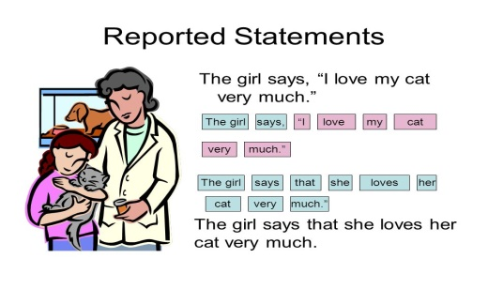  Ex:1 P:63  Ask students to open their books at page 63.  Tell students the sentences in Exercise 1 can all be found in the article on page 62 as reported speech.  Ask students to work alone to find the sentences in the article and copy them into their notebooks.  Check answers. | Students of the class are listed.  Students' attention is drawn to the lesson.  Determines the topic and purpose of the lesson  Students say different words from the picture and count one to hundred  Pupils complete the examples of reported speech from the text  ANSWERS  1 we wanted to go there  2 I'd do it  3 I couldn't do it  4 it was the most extraordinary thing he'd ever seen | The teacher to assess learners for their ability.  “Good job!  Well done!”  Formative Assessment  Good job!  Descriptor:  - complete the examples  - find the sentences in the article  Total: 2 point | Pictures
 | Ex: 2 P: 63  Put students into pairs.  Tell students to use the examples of reported speech they found in the article in Exercise 1 to help them complete the rules.  Check answers.  Ex: 3 P: 63  Tell students to look at the extracts and locate the verbs. Ask students to work alone to find the sentences in the report and choose the correct form of the verbs in the reported speech.  Check answers.  Ex: 4 P: 63  Read out the information in the Get it right! box. Point out that it is not possible to say She told she was sorry. Complete the first reported statement, eliciting the changes to the grammar that are required. Write the reported statement on the board, highlighting the way the sentence has changed.  Put students into pairs to complete the remaining sentences.  Check answers. | Pupils look at the sentences in Exercise 1 and the examples of reported speech in the text again. Then complete the rules  ANSWERS  1 the present simple changes to the past simple.  2 the past simple changes to the past perfect.  3 the present perfect changes to the past perfect.  4 will changes to would and can changes to could  Pupils Tom went back to his old school to tell them about his trip. Look at these extracts, then read the report and choose the correct form of the verbs.  ANSWERS  1 had always wanted  2 had  3 hadn't had  4 were  5 had been  6 would take  7 was  8 could  9 wanted  Pupils complete the reported statements  ANSWERS  1 Tom said he'd had the most fantastic time.  2 He told us he'd travelled with a group of friends.  3 He said Geography had always been his favourite subject.  4 Tom told us he'd worked in a supermarket to pay for the trip.  5 He said he'd need to save hard for the next trip.  6 He told us he couldn't afford another trip yet | Descriptor:  - look at the sentences  - complete the rules  Total: 2 point  Descriptor:  - look at these extracts,  - correct form of the verbs.  Total: 2 point  -Make CCQ questions Yes / No  Total: 10 point | Card  Worksheet  Students book
End of the lesson  5 min | FEEDBACK  Learners provide feedback on what they have learned at the lesson.  Ex:  Home task: | Ss evaluate each other and encourage classmate with phrases like:  Well done! Brilliant! Good job! I like it! |  | Poster Success

Short term plan: term 3

Unit 6 The natural world |  | Lesson 55
Teacher name:

Date:
Grade: 8 |  | Number present: | absent:
Lesson title | Vocabulary. Linking phrases
Learning objectives | 8.2.7.1 recognize typical features at word, sentence and text level of a growing range of spoken genres;  8.3.7.1 use appropriate subject-specific vocabulary and syntax to talk about a range of general topics, and some curricular topics
Lesson objectives | Learners will be able to:  - listen to a podcast about the Giant's Causeway.  - learn linking phrases.  - write about legends from my country or other parts of the world.
Value links | "Law and Order"  Know the basics of the legal system and human rights
Plan

Stages / Time | Teachers actions | Students actions | Assessment criteria | Resources
Beginning of the lesson  3 min  Middle of the lesson  Presentation part.  35 min | Organization moment :  1.Greeting.  Ask about the weather.  Warming-up  The teacher sets the lesson objectives, letting students know what to anticipate from the lesson.  Revise the language of the previous lesson.  Ex:1 P:64  Ask students to open their books at page 64.  Put students into pairs to answer the question about the photo.  Do not check answers at this point. Students will do that in Exercise 2 by listening to the recording  Ex: 2 P: 64  Before you play the recording, put the word causeway /'kɔ:zwe1/ on the board. Explain that it is a raised track or road that is used to cross ground that is wet or low. Tell students that the photo shows something called the  Giant's Causeway.  Tell students they are going to listen to a radio interview about the Giant's Causeway.  Students listen and decide if the sentences are true or false. Check answers | Students of the class are listed.  Students' attention is drawn to the lesson.  Determines the topic and purpose of the lesson  Students say different words from the picture  Pupils work with a partner. Look at the photo. Answer the question.  ANSWERS  Students own answer  Pupils listen to the radio interview. Are these sentences true or false?  ANSWERS  1 F (it is a natural formation)  2 F (it gives two explanations: one based on a legend and the other scientific)  3 F (the presenter prefers the first) | The teacher to assess learners for their ability.  “Good job!  Well done!”  Formative Assessment  Good job!  Descriptor:  - work with a partner  - answer the question  Total: 2 point  Descriptor:  - listen to the radio interview  - mark the statements  Total: 2 point | Pictures
 | .Ex: 3 P: 64  Refer students to sentences 1-8.  Play the recording for students to choose the correct option in each of the sentences.  Students can compare their answers in pairs before you check answers with the whole class  Ex: 4 P: 64  Refer students to the words and phrases in the box. Explain that they are used to connect parts of a sentence or an idea expressed in one sentence with one expressed in another.  Put students into pairs and ask them to complete the gapped sentences with the linking phrases. | Pupils listen again and choose the correct options  ANSWERS  1 Northern Ireland  2 Finn McCool  3 walk  4 bigger  5 dressed up like a baby boy  6 Finn was enormous  7 60  8 12  Pupils complete the sentences from the radio interview with the phrases in the box. Then listen and check.  ANSWERS  2 according to  3 so that  4 Rather than  5 In order to  6 As a result  7 of course  8 Then again | Descriptor:  - listen again  - correct the options  Total: 2 point  Descriptor:  - complete the sentences  - listen and check.  Total: 2 point  -Make CCQ questions Yes / No | Card  Worksheet  Students book
End of the lesson  5 min | FEEDBACK  Learners provide feedback on what they have learned at the lesson.  Ex:  Home task: | Ss evaluate each other and encourage classmate with phrases like:  Well done! Brilliant! Good job! I like it! |  | Poster Success

Short term plan: term 3

Unit 6 The natural world |  | Lesson 56
Teacher name:

Date:
Grade: 8 |  | Number present: | absent:
Lesson title | Language focus 2 Reported questions
Learning objectives | 8.2.5.1 recognise the opinion of the speaker(s) with little or no support in extended talk on a wide range of general and curricular topics  8.4.4.1 read a growing range of extended fiction and non-fiction texts on familiar and some unfamiliar general and curricular topics
Lesson objectives | Learners will be able to:  -learn reported questions and indirect questions. report a conversation about a natural feature.
Value links | "Law and Order"  Observance of norms and rules of order and justice understand the need
Plan

Stages / Time | Teachers actions | Students actions | Assessment criteria | Resources
Beginning of the lesson  5 min  Middle of the lesson  Presentation part.  35 min | Organization moment :  1.Greeting.  Ask about the weather.  Warming-up  The teacher sets the lesson objectives, letting students know what to anticipate from the lesson.  Revise the language of the previous lesson.  Lead – In  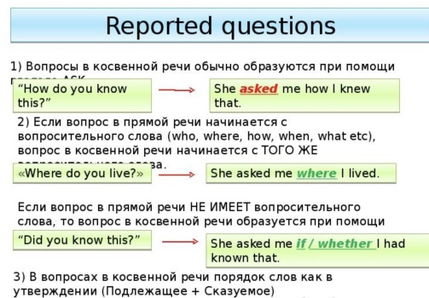  Ex:1 P:65  Ask students to open their books at page 65.  Students complete the rules looking at the examples from the listening on page 64 to help them.  For further information and additional exercises, student can turn to page 118 of the Grammar reference. | Students of the class are listed.  Students' attention is drawn to the lesson.  Determines the topic and purpose of the lesson  Students say different words from the picture  Pupils complete the examples from the listening  ANSWERS  1 In reported Yes/No questions, we use if.  2 The word order is different in direct and reported questions.  3 The tense changes in reported questions.  4 Reported questions don't have question marks | The teacher to assess learners for their ability.  “Good job!  Well done!”  Formative Assessment  Good job!  Descriptor:  -  Descriptor:  - complete the examples  Total: 2 point | Pictures
 | Ex: 2 P: 65  Refer students to the example reported question. Put students into pairs to order the words in questions 2-5.  Ex: 3 P: 65  Do this exercise with the whole class.  For further information and additional exercises, students can turn to page 118 of the Grammar reference section.  Ex: 4 P: 65  Read out the example.  Put students into pairs to complete the remaining the reported requests and commands. | Pupils put the words in order to complete the reported questions  ANSWERS  2 I asked her if she thought legends were interesting.  3 They asked him how old the rocks were.  4 She asked me what I'd learned from the radio show.  5 I asked her which explanation she preferred.  Pupils look at the examples from the listening on page 64, then complete the rules.  ANSWERS  1 we use ask or tell + to infinitive form of the verb.  2 if the request or command is negative, we use not  3 We use ask for requests and tell for commands.  4 Requests are more polite than commands.  Pupils read the direct speech and complete the reported requests and commands.  ANSWERS  2 He told the children to stop shouting.  3 The teacher told us not to talk in the library.  4 He told her not to put her shoes on the chair.  5 She asked them to wait ten minutes. | Descriptor:  - put the words in order  - complete the reported questions  Total: 2 point  Descriptor:  - look at the examples  - complete the rules  Total: 2 point  Descriptor:  - read the direct speech  - complete the reported requests  Total: 2 point  -Make CCQ questions Yes / No | Card  Worksheet  Students book
End of the lesson  5 min | FEEDBACK  Learners provide feedback on what they have learned at the lesson.  Ex:  Home task: | Ss evaluate each other and encourage classmate with phrases like:  Well done! Brilliant! Good job! I like it! |  | Poster Success

Short term plan: term 3

Unit 6 The natural world |  | Lesson 57
Teacher name:

Date:
Grade: 8 |  | Number present: | absent:
Lesson title | Discover Culture
Learning objectives | 8.1.5.1 use feedback to set personal learning objectives  8.2.5.1 recognise the opinion of the speaker(s) with little or no support in extended talk on a wide range of general and curricular topics  8.3.7.1 use appropriate subject-specific vocabulary and syntax to talk about a range of general topics, and some curricular topics
Lesson objectives | Learners will be able to:  -watch a video about a lost civilisation in Peru.  - talk about visiting archaeological sites or going to exhibitions of ancient artefacts
Value links | "Law and Order"  Ensuring the protection and safety of society understand the importance of law and order as
Plan

Stages / Time | Teachers actions | Students actions | Assessment criteria | Resources
Beginning of the lesson  5 min  Middle of the lesson  Presentation part.  35 min | Organization moment :  1.Greeting.  Ask about the weather.  Warming-up  The teacher sets the lesson objectives, letting students know what to anticipate from the lesson.  Revise the language of the previous lesson.  Lead – In  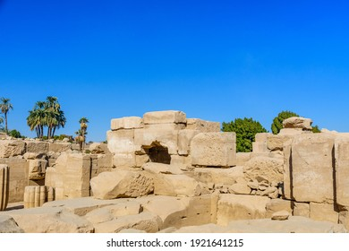  Ex:1 P:66  Ask students to open their books at page 66. Put students into pairs to talk about what the link between the four photos might be. | Students of the class are listed.  Students' attention is drawn to the lesson.  Determines the topic and purpose of the lesson  Students say different words from the picture  Pupils work with a partner. Look at the photos. Answer the question.  ANSWERS  Students own answer. | The teacher to assess learners for their ability.  “Good job!  Well done!”  Formative Assessment  Good job!  Descriptor:  - work with a partner  - look at the photos.  - answer the question  Total: 2 point | Pictures
 | Ex: 2 P: 66  Read out the two questions.  Play the video for students to check their answers to Exercise  1 as well as answer the two questions.  Check answers  Ex: 3 P: 66  Ask students to look at the information in the list a-f, which refers to different parts of the video.  Tell students they are going to watch the video and order the information.  Play the video.  Check answers.  Ex: 4 P: 66  Ask students to say whether number or words are needed to complete the gapped sentences.  Play the video for students to complete the sentences.  Check answers. | Pupils watch the video and check your answers to Exercise 1. What do the objects they found tell us about the Chiribaya? How were llamas important?  ANSWERS  Students own answer.  Pupils before you watch the video again, put these sections in the correct order. Then watch and check your answers.  ANSWERS  f – d – b – e – a – c  Pupils watch the video again and complete the sentences  ANSWERS  1 hottest; driest  2 15 .  3 ancient  4 buildings; monuments  5 rich; powerful  6 tropical birds | Descriptor:  - watch the video  - answer the question  Total: 2 point  Descriptor:  - watch the video again  - put these sections in the correct orde  Total: 2 point  Descriptor:  - watch the video  - complete the sentences  Total: 2 point  -Make CCQ questions Yes / No | Card  Worksheet  Students book
End of the lesson  5 min | FEEDBACK  Learners provide feedback on what they have learned at the lesson.  Ex:  Home task: | Ss evaluate each other and encourage classmate with phrases like:  Well done! Brilliant! Good job! I like it! |  | Poster Success

Short term plan: term 3

Unit 6 The natural world |  | Lesson 58
Teacher name:

Date:
Grade: 8 |  | Number present: | absent:
Lesson title | Reading A magazine article
Learning objectives | 8.5.3.1 write with moderate grammatical accuracy on a limited range of familiar general and curricular topics  8.6.1.10 use present continuous forms for present and future meaning and past continuous, including some passive forms, on a range of familiar general and curricular topics;
Lesson objectives | Learners will be able to:  -read an article about the Pueblo people.  - learn words in context.  - talk about life might have been like for the Pueblo people 1,000 years ago.
Value links | "Creativity and Innovation"  Monitoring, measuring, conducting experiments and experiments ability;
Plan

Stages / Time | Teachers actions | Students actions | Assessment criteria | Resources
Beginning of the lesson  5 min  Middle of the lesson  Presentation part.  35 min | Organization moment :  1.Greeting.  Ask about the weather.  Warming-up  The teacher sets the lesson objectives, letting students know what to anticipate from the lesson.  Revise the language of the previous lesson.  Lead – In  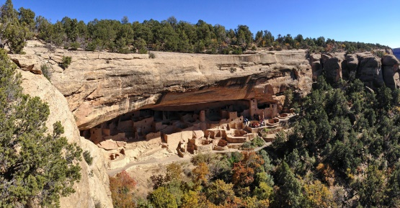  Ex:1 P:67  Ask students to open their books at page 67.  Refer students to the photos and the title of the article. Put students into pairs to answer the three questions.  Do not confirm or reject students' ideas at this point.  Students will check their answers in Exercise 2. | Students of the class are listed.  Students' attention is drawn to the lesson.  Determines the topic and purpose of the lesson  Students say different words from the picture  Pupils work with a partner. Look at the photos. Answer the question  ANSWERS  Students own answer. | The teacher to assess learners for their ability.  “Good job!  Well done!”  Formative Assessment  Good job!  Descriptor:  - work with a partner  - look at the photos.  - answer the question  Total: 2 point | Pictures
 | Ex: 2 P: 67  Ask students to read the article to check the answers they gave in Exercise 1.  Read out the information in the FACT! box. Ask students if they can name some of the tallest buildings in the United States: One World Trade Center and the Empire State Building in New York; the Trump Tower in Chicago. You could also ask students if they can name some of the tallest buildings in their country.  Ex: 3 P: 667  Tell students that they do not have to read the article all the way through again. They should instead scan it for information. This they can do by first identifying the key words and phrases in the sentences that they need to look for, and then scanning the text to find these words and phrases. For example, the key words in sentence 1 are Mesa Verde National Park and Mexico.  Ex: 4 P: 67  Refer students to the highlighted words in the article.  Match the first highlighted word in the text with one of the definitions 1-5 as an example.  Put students into pairs to complete the exercise.  Check answers. | Pupils read the magazine article and check your answers.  ANSWERS  1 the Pueblo people, a Native American civilisation  2 from 600 to 1300 AD 3 to be safe  Pupils read the article again. Find a factual mistake in each sentence below  ANSWERS  1 The Mesa Verde National Part is in the United States.  2 The Pueblo people lived there for over 700 years.  3 The word pueblo means village.  4 The Balcony House is made up of 40 rooms.  5 The only door is at the top of a 10-metre high wooden ladder.  6 The Pueblo people used ladders and ropes to protect themselves from enemies.  Pupils match the highlighted words in the article with the definitions.  ANSWERS  1 maze  2 canyons  3 dwellings  4 settlers  5 borders | Descriptor:  - read the magazine article  - check your answers  Total: 2 point  Descriptor:  - read the article again.  - find a factual mistake  Total: 2 point  Descriptor:  - match the highlighted words  - complete the exercise.  Total: 2 point  -Make CCQ questions Yes / No | Card  Worksheet  Students book
End of the lesson  5 min | FEEDBACK  Learners provide feedback on what they have learned at the lesson.  Ex:  Home task: | Ss evaluate each other and encourage classmate with phrases like:  Well done! Brilliant! Good job! I like it! |  | Poster Success

Short term plan: term 3

Unit 6 The natural world |  | Lesson 59
Teacher name:

Date:
Grade: 8 |  | Number present: | absent:
Lesson title | Speaking Clarifying
Learning objectives | 8.2.2.1 understand with little or no support most specific information in extended talk on a wide range of general and curricular topics;  8.5.3.1 write with moderate grammatical accuracy on a limited range of familiar general and curricular topics  8.6.3.1 use a growing variety of compound adjectives and adjectives as participles and some comparative structures including not as…as, much …than to indicate degree on a range of familiar general and curricular topics
Lesson objectives | Learners will be able to:  - watch teenagers talking about the biggest lie they have ever been told.  - listen to a journalist interviewing a footballer.  - practise making ideas clearer and more intelligible.
Value links | "Creativity and Innovation"  Ability to find optimal ways to solve educational tasks to use new and already familiar algorithms combining, using them in solving non-standard problems
Plan

Stages / Time | Teachers actions | Students actions | Assessment criteria | Resources
Beginning of the lesson  5 min | Organization moment :  1.Greeting.  Ask about the weather  Warming-up  The teacher sets the lesson objectives, letting students know what to anticipate from the lesson.  Describe The Picture  Revise the language of the previous lesson.  Lead – In    Ex:1 P:68  Ask students to open their books at page 68.  Tell students they are going to watch some teenagers answering the following question:  What's the biggest lie you've ever been told?  Play the video for students to match the person with the lie.  Students work alone to complete the exercise. Check answers. Students should give as much detail as they can in their answers | Students of the class are listed.  Students' attention is drawn to the lesson.  Determines the topic and purpose of the lesson  Students say different words from the picture  Pupils watch or listen to the teenagers. Match the person or people to the lie  ANSWERS  a classmate  b ex-best friend  c big brother  d everyone  e granny  f classmate | The teacher to assess learners for their ability.  “Good job!  Well done!”  Formative Assessment  Good job!  Descriptor:  - watch or listen to the teenagers  - match the person or people  Total: 2 point | Pictures
Middle of the lesson  Presentation part.  30 min | Ex: 2 P: 68  Put students into pairs to ask and answer the question  Ex: 3 P: 68  Tell students they are going to listen to an interview.  Play the recording.  Students listen and answer the question.  Check answer.  Ex: 4 P: 68  Refer students to the phrases in the Useful language box. Point out that the question Would you like to comment on ? is not commonly used by people outside the media.  Ask students to complete the conversation using the phrases in the Useful language box.  Ex: 5 P: 68  Play the recording again for students to check their answers. | Pupils what’s the biggest lie you’ve ever been told? Ask and answer with your partner  ANSWERS  Students own answer.  Pupils listen to a journalist interviewing a footballer. Which thing that she asks about is true?  ANSWERS  He has bought a Ferrari.  Pupils complete the conversation with the useful language.  ANSWERS  Students own answer.  Pupils listen again and check your answers  ANSWERS  2 is it true that  3 absolutely  4 Is that right  5 are completely false  6 like to comment on  7 totally untrue | Descriptor:  - ask and answer with your partner  - check your answers  Total: 2 point  Descriptor:  - listen to a journalist interviewing a footballer.  - answer the question.  Total: 2 point  Descriptor:  - complete the conversation wit  Total: 2 point  -Make CCQ questions Yes / No | Card  Worksheet  Students book
End of the lesson  5 min | FEEDBACK  Learners provide feedback on what they have learned at the lesson.  Ex:  Home task: | Ss evaluate each other and encourage classmate with phrases like:  Well done! Brilliant! Good job! I like it! |  | Poster Success

Short term plan: term 3

Unit 6 The natural world |  | Lesson 60
Teacher name:

Date:
Grade: 8 |  | Number present: | absent:
Lesson title | Writing An online article
Learning objectives | 8.2.1.1 understand with little or no support the main points in extended talk on a wide range of general and curricular topics  8.3.7.1 use appropriate subject-specific vocabulary and syntax to talk about a range of general topics, and some curricular topics  8.4.2.1 understand specific information and detail in texts on a growing range of familiar general and curricular topics, including some extended texts
Lesson objectives | Learners will be able to:  - read an article about the wildlife crisis.  - learn about describing the amount of something.  - write an online article about animals in danger.
Value links | "Creativity and Innovation"  Use of various cognitive tools, knowledge about the world be able to collect (linguistic, reading culture, information, service in the digital environment)
Plan

Stages / Time | Teachers actions | Students actions | Assessment criteria | Resources
Beginning of the lesson  5 min  Middle of the lesson  Presentation part.  35 min | Organization moment :  1.Greeting.  Ask about the weather.  Warming-up  The teacher sets the lesson objectives, letting students know what to anticipate from the lesson.  Revise the language of the previous lesson.  Lead – In    Ex:1 P:69  Ask students to open their books at page 69.  Students read the article about the wildlife crisis and an the question. | Students of the class are listed.  Students' attention is drawn to the lesson.  Determines the topic and purpose of the lesson  Students say different words from the picture  Pupils look at the title and read the article. In general, is the situation with falling numbers of animals getting better or worse?  ANSWERS  It's getting worse. | The teacher to assess learners for their ability.  “Good job!  Well done!”  Formative Assessment  Good job!  Descriptor:  - look at the title  - read the article  Total: 2 point | Pictures
 | Ex: 2 P: 69  Ask students to read the article. Students should then make notes on why the wildlife crisis is so worrying, a bad thing and falling.  Students can compare answers in pairs before you check answers with the class as a whole.  Ex: 3 P: 69  Read out the information in the Useful language box about phrases used to describe amounts. Ask students to work alone to find five examples of such phrases.  Check answers.  Ex: 4 P: 69  Ask students to work alone to complete the sentences the words and phrases in the box.  When checking answers, challenge stronger students by asking them to justify the answer they give. | Pupils read the article again and make notes under these headings:  ANSWERS  a It's so worrying because the number of wild animals on Earth had fallen by about 60%.  b The main threats to animals are of farming, building projects and people cutting down trees.  c There are hopeful signs because the number of tigers left in the world is increasing  Pupils look at the Useful language box. Can you fi nd any similar words and phrases in the article?  ANSWERS  as high as, nearly, more than, fewer than  Pupils complete the sentences with the phrases in the box  ANSWERS  1 approximately  2 estimated  3 just over  4 more than  5 well over  6 just under | Descriptor:  - read the article  - make notes under these headings  Total: 2 point  Descriptor:  - look at the Useful language box  - answer the question.  Total: 2 point  Descriptor:  - complete the sentences with the phrases  Total: 2 point  -Make CCQ questions Yes / No | Card  Worksheet  Students book
End of the lesson  5 min | FEEDBACK  Learners provide feedback on what they have learned at the lesson.  Ex:  Home task: | Ss evaluate each other and encourage classmate with phrases like:  Well done! Brilliant! Good job! I like it! |  | Poster Success

Short term plan: term 3

Unit 6 The natural world |  | Lesson 61
Teacher name:

Date:
Grade: 8 |  | Number present: | absent:
Lesson title | CLIL: Biology Extinction
Learning objectives | 8.2.2.1 understand with little or no support most specific information in extended talk on a wide range of general and curricular topics  8.4.8.1 use familiar and some unfamiliar paper and digital reference resources with little support to check meaning and extend understanding  8.5.3.1 write with moderate grammatical accuracy on a limited range of familiar general and curricular topics
Lesson objectives | Learners will be able to:  - learn about how the honeybee is at risk of extinction. design a poster informing people about the risk of extinction to the honeybee
Value links | "Creativity and Innovation"  Monitoring, measuring, conducting experiments and experiments ability;
Plan

Stages / Time | Teachers actions | Students actions | Assessment criteria | Resources
Beginning of the lesson  5 min  Middle of the lesson  Presentation part.  35 min | Organization moment :  1.Greeting.  Ask about the weather.  Warming-up  The teacher sets the lesson objectives, letting students know what to anticipate from the lesson.  Revise the language of the previous lesson.  Lead – In  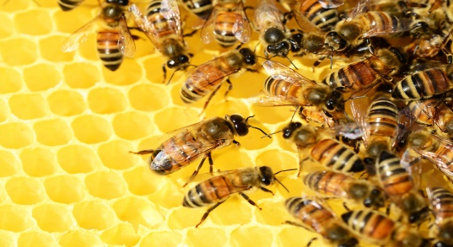  Ex:1 P:70  Ask students to open their books at page 70. Put students into pairs and ask them to look at the photo and answer the questions.  Tell students that they should try to express what they want to say even if they don't know some words. | Students of the class are listed.  Students' attention is drawn to the lesson.  Determines the topic and purpose of the lesson  Students say different words from the picture  Ex:1 P:70  Ask students to open their books at page 70. Put students into pairs and ask them to look at the photo and answer the questions.  Tell students that they should try to express what they want to say even if they don't know some words. | The teacher to assess learners for their ability.  “Good job!  Well done!”  Formative Assessment  Good job!  Descriptor:  - work with a partner  - answer the questions.  Total: 2 point | Pictures
 | Ex: 2 P: 70  Ask students to read the text about the bees and ask the question.  Check answers.  Ex: 3 P: 70  Ask students to work alone to match the highlighted words in the article with the definitions 1-6.  Ex: 4 P: 70  Tell students they are going to listen to Lisa taking to her father about bees.  Play the recording for students to note down what it is that Lisa wants her father to do.  Check answers  Ex: 5 P: 70  Refer students to the fact file.  Play the recording again for students to copy and complete it | Pupils read the article about the honeybee. Why are they dying?  ANSWERS  they don't have enough food. Diseases and chemicals kill  Pupils match the highlighted words in the article with the definitions.  ANSWERS  1 mites  2 extinction  3 hive  4 pollination  5 hibernation  6 pollinators  Pupils listen to Lisa telling her father about bees. What does Lisa want her father to do?  ANSWERS  She wants him to help save the bees by planting more flowers in the garden, not using chemicals, buying food grown without chemicals and keeping their own hives  Pupils listen again to the conversation. Copy and complete the bee fact fi le.  ANSWERS  1 five years  2 up to 2,500  3 on all continents except Antarctica  4 two or three times the amount they need | Descriptor:  - read the article  - answer the questions.  Total: 2 point  Descriptor:  - answer the questions.  - complete the sentences  Total: 2 point  Descriptor:  - listen to Lisa telling her father  - answer the questions.  Total: 2 point  -Make CCQ questions Yes / No | Card  Worksheet  Students book
End of the lesson  5 min | FEEDBACK  Learners provide feedback on what they have learned at the lesson.  Ex:  Home task: | Ss evaluate each other and encourage classmate with phrases like:  Well done! Brilliant! Good job! I like it! |  | Poster Success

Short term plan: term 3

Unit 6 The natural world |  | Lesson 62
Teacher name:

Date:
Grade: 8 |  | Number present: | absent:
Lesson title | Extra reading  Summative assessment for the unit 6
Learning objectives | 8.2.1.1 understand with little or no support the main points in extended talk on a wide range of general and curricular topics  8.3.7.1 use appropriate subject-specific vocabulary and syntax to talk about a range of general topics, and some curricular topics  8.4.5.1 deduce meaning from context in short texts and some extended texts on a growing range of familiar general and curricular topics;
Lesson objectives | Learners will be able to:  - read an article about tulips.  - decide if information about the text is true or false.  - discuss which flower should become Kazakhstan's national flower
Value links | "Creativity and Innovation"  Ability to find optimal ways to solve educational tasks to use new and already familiar algorithms combining, using them in solving non-standard problems
Plan

Stages / Time | Teachers actions | Students actions | Assessment criteria | Resources
Beginning of the lesson  5 min  Middle of the lesson  Presentation part.  35 min | Organization moment :  1.Greeting.  Ask about the weather.  Warming-up  The teacher sets the lesson objectives, letting students know what to anticipate from the lesson.  Revise the language of the previous lesson.  Lead – In    Ex:1 P:71  Draw attention to the questions. Check students' comprehension of occasions eliciting a few examples, e.g. birthdays, weddings, informal visit, etc.  Students spend a few seconds thinking of their answers. Then they discuss in pairs or small groups.  Elicit ideas from individual students. | Students of the class are listed.  Students' attention is drawn to the lesson.  Determines the topic and purpose of the lesson  Students say different words from the picture  Pupils answer the question.  ANSWERS  Students own answer | The teacher to assess learners for their ability.  “Good job!  Well done!”  Formative Assessment  Good job!  Descriptor:  - answer the questions.  Total: 2 point | Pictures
 | Ex: 2 P: 71  Before students read the text, find out what they know about tulips. Ask them to skim read the text once and find one more new piece of information  Elicit ideas from the class.  Read out the statements. Give students five minutes to scan the text and mark the statements true or false. They must also correct the false sentences.  Students can compare answers in pairs before you check them with the class.  Check answers.  Ex: 3 P: 71  Students work in pairs. They read paragraph 2 again and help each other to explain what 'tulip mania' means in the context of the text.  If necessary, elicit and discuss the meaning of 'crazy about' in the text ('extremely fond of').  Check answers as a class.  Summative assessment for the unit 6 | Pupils read the text. Are the sentences true (T) or false (F)? Correct the false sentences  ANSWERS  1 F (That's what people often think, but they come from Kazakhstan.) 2 T  3 F (They paid high prices for tulips in the 17th century.)  4 F (They come out in spring.)  5 T  6 F (Many types of tulip are protected because people pick them.)  Pupils read paragraph 2 again. What does ‘tulip mania’ mean? Explain to a partner  ANSWERS  "Tulip mania' means that tulips were extremely popular for a short period of time | Descriptor:  - read the text  - mark the statements  Total: 2 point  Descriptor:  - read paragraph 2  - answer the question.  Total: 2 point  -Make CCQ questions Yes / No | Card  Worksheet  Students book
End of the lesson  5 min | FEEDBACK  Learners provide feedback on what they have learned at the lesson.  Ex:  Home task: | Ss evaluate each other and encourage classmate with phrases like:  Well done! Brilliant! Good job! I like it! |  | Poster Success

Short term plan: term 3

Unit 7 Travel and transport |  | Lesson 63
Teacher name:

Date:
Grade: 8 |  | Number present: | absent:
Lesson title | Vocabulary Travel and transport
Learning objectives | 8.2.1.1 understand with little or no support the main points in extended talk on a wide range of general and curricular topics  8.3.7.1 use appropriate subject-specific vocabulary and syntax to talk about a range of general topics, and some curricular topics  8.4.8.1 use familiar and some unfamiliar paper and digital reference resources with little support to check meaning and extend understanding
Lesson objectives | Learners will be able to:  - learn vocabulary for travel and transport.  - listen to people talking about travelling.  - talk about travelling in different situations.
Value links | "Creativity and Innovation"  Use of various cognitive tools, knowledge about the world be able to collect (linguistic, reading culture, information, service in the digital environment)
Plan

Stages / Time | Teachers actions | Students actions | Assessment criteria | Resources
Beginning of the lesson  5 min  Middle of the lesson  Presentation part.  35 min | Organization moment :  1.Greeting.  Ask about the weather.  Warming-up  The teacher sets the lesson objectives, letting students know what to anticipate from the lesson.  Revise the language of the previous lesson.  Lead – In    Ex:1 P:73  Ask students to open their books at page 73. Put students into pairs to match the words and phrases with the photos. Point out that there is an element of guesswork in this exercise as only small parts of the experiences are shown in the photos. Students may struggle in particular with photos b and e.  Play the recording for students to listen, check their answers and repeat the phrases. | Students of the class are listed.  Students' attention is drawn to the lesson.  Determines the topic and purpose of the lesson  Students say different words from the picture  Pupils match the photos a–h with the words and phrases in the box. Then listen, check and repeat  ANSWERS  a travel by rail  b go backpacking  c see the sights  d arrive at your destination  e take a cab  f reserve a seat  g go abroad  h hire a car | The teacher to assess learners for their ability.  “Good job!  Well done!”  Formative Assessment  Good job!  Descriptor:  - match the photos  - listen, check and repeat  Total: 2 point | Pictures
 | Ex: 2 P: 73  Put students into pairs.  Ask students to complete the sentences with phrases from Exercise 1.  Check answers  Ex: 3 P: 73  Tell students they are going to listen to four conversations about people on holiday out of the country.  Play the recording.  Check answers. | Pupils complete the sentences with phrases from Exercise 1  ANSWERS  2 reach your destination 3 reserve a seat  4 travel by rail  5 go backpacking  6 take a cab  7 hire a car  8 see the sights  Pupils listen to four conversations, and say what the people are doing. Use phrases from Exercise 1.  ANSWERS  1 She's going abroad.  2 He's reserving a seat.  3 They're seeing the sights  4 They're travelling by rail. | Descriptor:  - complete the sentences  - complete the sentences with phrases  Total: 2 point  Descriptor:  - listen to four conversations  - say what the people are doing  Total: 2 point  -Make CCQ questions Yes / No | Card  Worksheet  Students book
End of the lesson  5 min | FEEDBACK  Learners provide feedback on what they have learned at the lesson.  Ex:  Home task: | Ss evaluate each other and encourage classmate with phrases like:  Well done! Brilliant! Good job! I like it! |  | Poster Success

Short term plan: term 3

Unit 7 Travel and transport |  | Lesson 64
Teacher name:

Date:
Grade: 8 |  | Number present: | absent:
Lesson title | Reading: An online article
Learning objectives | 8.2.5.1 recognise the opinion of the speaker(s) with little or no support in extended talk on a wide range of general and curricular topics  8.3.7.1 use appropriate subject-specific vocabulary and syntax to talk about a range of general topics, and some curricular topics  8.4.8.1 use familiar and some unfamiliar paper and digital reference resources to check meaning and extend understanding
Lesson objectives | Learners will be able to:  -read an online article about different types of transport.  -learn words in context.  -talk about the best forms of transport for a big city
Value links | "Creativity and Innovation"  Monitoring, measuring, conducting experiments and experiments  ability;
Plan

Stages / Time | Teachers actions | Students actions | Assessment criteria | Resources
Beginning of the lesson  5 min  Middle of the lesson  Presentation part.  35 min | Organization moment :  1.Greeting.  Ask about the weather.  Warming-up  The teacher sets the lesson objectives, letting students know what to anticipate from the lesson.  Revise the language of the previous lesson.  Lead – In    Ex:1 P:74  Ask students to open their books at page 74.  Refer students to the photos and elicit answers from the class to the questions.  Do not confirm or reject students' ideas at this point.  Students will check their ideas by reading the text in Exercise 2 | Students of the class are listed.  Students' attention is drawn to the lesson.  Determines the topic and purpose of the lesson  Students say different words from the picture  Pupils look at the photos of London. Name the different types of transport.  ANSWERS  Students own answer | The teacher to assess learners for their ability.  “Good job!  Well done!”  Formative Assessment  Good job!  Descriptor:  - look at the photos  - Name the different types of transport.  Total: 2 point | Pictures
 | Ex: 2 P: 74  Ask students to read the text and answer the questions in pairs. Refer students to the information in the FACT! box. To help students understand how challenging driving a taxi can be, especially in a large city with millions of resident and tourists moving around every day.  Ex: 3 P: 74  Refer students to text. Check students remember the meaning of the word Tube. (It is an alternative name to the word Underground for London's trains.)  Put students into pairs and ask them to correct the false statements with information from the text. Help weaker students by guiding them to the part of the text which will  Ex: 4 P: 74  Refer students to definitions 1-5.  Ask students to work alone to match the highlighted words in the article with the definitions.  Check answers and then drill the pronunciation of the words in the list. | Pupils read the text and answer the questions in pairs  ANSWERS  1 bus  2 London Underground (the Tube)  3 cycling  4 taxi (cab)  Pupils True or False? Correct the false statements  ANSWERS  1 True  2 F Over 4.5 million people 3 F The Tube is often very crowded  4 F You usually don't have to wait a long time  5 T  6 F There are 750 'stations'  Pupils match the words from the text with the definitions.  ANSWERS  1 d  2 e  3 b  4 c  5 a | Descriptor:  - read the text  - answer the questions  Total: 2 point  Descriptor:  - mark the statements  - correct the false statements  Total: 2 point  Descriptor:  - match the words  Total: 2 point  -Make CCQ questions Yes / No | Card  Worksheet  Students book
End of the lesson  5 min | FEEDBACK  Learners provide feedback on what they have learned at the lesson.  Ex:  Home task: | Ss evaluate each other and encourage classmate with phrases like:  Well done! Brilliant! Good job! I like it! |  | Poster Success

Short term plan: term 3

Unit 7 Travel and transport |  | Lesson 65
Teacher name:

Date:
Grade: 8 |  | Number present: | absent:
Lesson title | Language focus 1 The passive: present simple, past simple and will
Learning objectives | 8.4.8.1 use familiar and some unfamiliar paper and digital reference resources to check meaning and extend understanding  8.5.1.1 plan, write, edit and proofread work at text level with little support on a range of general and curricular topics  8.2.5.1 recognise the opinion of the speaker(s) with little or no support in extended talk on a wide range of general and curricular topics
Lesson objectives | Learners will be able to:  -learn the present and past simple passive.  -Jearn the passive with will.  -talk about inventions from the past, everyday objects and future inventions
Value links | "Creativity and Innovation"  Ability to find optimal ways to solve educational tasks to use new and already familiar algorithms combining, using them in solving non-standard problems
Plan

Stages / Time | Teachers actions | Students actions | Assessment criteria | Resources
Beginning of the lesson  5 min  Middle of the lesson  Presentation part.  35 min | Organization moment :  1.Greeting.  Ask about the weather.  Warming-up  The teacher sets the lesson objectives, letting students know what to anticipate from the lesson.  Revise the language of the previous lesson.  Lead – In  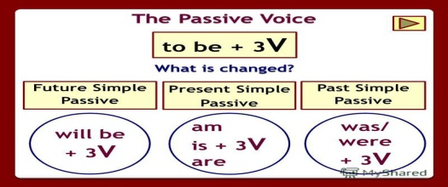  Ex:1 P:75  Ask students to open their books at page 75.  Tell students that the gapped sentences are from the text on page 74.  Ask students to copy the sentences into their notebooks and complete them.  Check answers.  For further information and additional exercises, students | Students of the class are listed.  Students' attention is drawn to the lesson.  Determines the topic and purpose of the lesson  Students say different words from the picture  Pupils complete the examples from the text on page 74. Then match the beginnings and the ends of the sentences to complete the rules.  ANSWERS  Students own answer | The teacher to assess learners for their ability.  “Good job!  Well done!”  Formative Assessment  Good job!  Descriptor:  - complete the examples  - match the beginnings and the ends  Total: 2 point | Pictures
 | Ex: 2 P: 75  Read out the example sentence.  Put students into pairs to complete the remaining sentences using the passive form of the verbs in bold. Ask them to check whether a singular or plural form of be is needed in each case.  Check answers  Ex: 3 P: 75  Ask students to look at the photos and name the types of trains shown.  Choose the correct form of the verb in number 1 as an example. Ask why designed and built is the correct choice (Answer: The sentence is in the active voice and the subject is George Stephenson).  Ask students to work alone to choose the correct form of the verbs.  Check answer  Ex: 4 P: 75  Tell students they have to think of three objects to go into each of the three categories.  Elicit the different passive forms that students will need to use in order to complete the task, e.g. the TV was invented in the 20th century. Computers are used every day in schools and homes. Digital implants will be invented in the next 20 years. | Pupils complete the second sentence in each pair using a passive form of the verb in bold  ANSWERS  2 wasn't introduced  3 were, built  4 was saved  5 are, caught  3 'll be driven  Pupils choose the correct form of the verbs in the texts below. Then listen and check  ANSWERS  1 designed and built  2 was watched  3 was completed  4 were gradually replaced  5 are taken  6 cover  7 will be built  8 will probably drive  Pupils think of three objects for each of the categories below  ANSWERS  Students own answer | Descriptor:  - complete the second sentence in each pair  - use a passive form of the verb  Total: 2 point  Descriptor:  - choose the correct  - listen and check  Total: 2 point  Descriptor:  - think of three objects for each  Total: 2 point  -Make CCQ questions Yes / No | Card  Worksheet  Students book
End of the lesson  5 min | FEEDBACK  Learners provide feedback on what they have learned at the lesson.  Ex:  Home task: | Ss evaluate each other and encourage classmate with phrases like:  Well done! Brilliant! Good job! I like it! |  | Poster Success

Short term plan: term 3

Unit 7 Travel and transport |  | Lesson 66
Teacher name:

Date:
Grade: 8 |  | Number present: | absent:
Lesson title | Listening A radio interview
Learning objectives | 8.1.8.1 develop intercultural awareness through reading and discussion  8.3.7.1 use appropriate subject-specific vocabulary and syntax to talk about a range of general topics, and some curricular topics
Lesson objectives | Learners will be able to:  -listen to a radio interview about different kinds of holiday.  -learn and practise using more -ed and -ing adjectives
Value links | Integrity – Integrity is the quality of having strong moral principles. So, a person with integrity will always act with honesty and adhere to their own moral code regardless of what others do.
Value links | "Creativity and Innovation"  Use of various cognitive tools, knowledge about the world be able to collect (linguistic, reading culture, information, service in the digital environment)
Plan

Stages / Time | Teachers actions | Students actions | Assessment criteria | Resources
Beginning of the lesson  5 min | Organization moment :  1.Greeting.  Ask about the weather.  Warming-up  The teacher sets the lesson objectives, letting students know what to anticipate from the lesson.  Revise the language of the previous lesson.  Lead – In  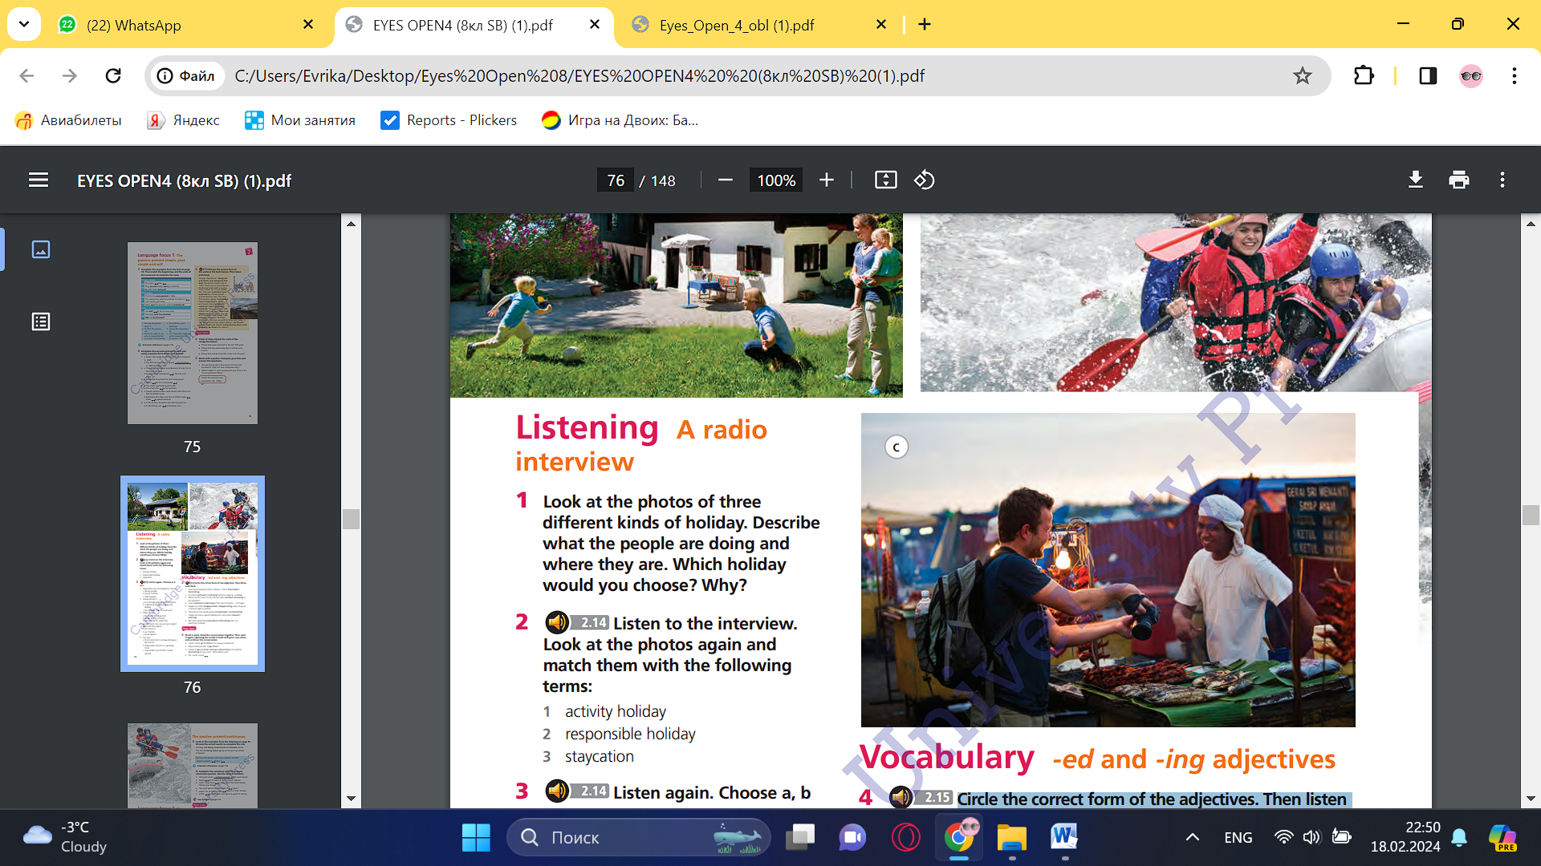  Ex:1 P:76  listen to a radio interview about different kinds of holiday.  learn and practise using more -ed and -ing adjectives | Students of the class are listed.  Students' attention is drawn to the lesson.  Determines the topic and purpose of the lesson  Students say different words from the picture  Pupils look at the photos of three different kinds of holiday. Describe what the people are doing and where they are.  ANSWERS  Students own answer | The teacher to assess learners for their ability.  “Good job!  Well done!”  Formative Assessment  Good job!  Descriptor:  - look at the photos  - practise using more -ed and -ing adjectives  Total: 2 point | Pictures
Middle of the lesson  Presentation part.  30 min | Ex: 2 P: 76  Tell students they are going to listen to lecturer in Travel and Tourism at Bramlingham University talking about a survey into the latest holiday trends.  Play the recording for students to check the answers that they gave in Exercise 1.  Students can compare their answers in pairs before you check answers with the whole class.  Ex: 3 P: 76  Refer students back to the photos in Exercise 1, which are labelled a, b and c.  Play the recording again for students to listen and match the photos with the sentences.  Check answers with the whole class  Ex: 4 P: 76  Refer students to the words and phrases in the sentences. Remind students that -ed and -ing endings are used at the end of verbs to form adjectives and modify the meaning of them. e.g. -ing adjectives describe the effect and -ed adjectives describe how a person feels, e.g. That was an exciting game. We were really excited about the game. Tell students they are going to choose the correct form of the adjectives. Then, they will listen and check their answers. | Pupils listen to the interview. Look at the photos again and match them with the following terms:  ANSWERS  a staycation  b activity holiday  c responsible holiday  Pupils listen again. Choose a, b or c.  ANSWERS  1 b  2 b  3 c  4 a  5 b  Pupils circle the correct form of the adjectives. Then listen and check  ANSWERS  1 fascinating  2 confusing  3 shocked  4 surprised  5 disappointed  6 uninteresting  7 relaxed  8 exhausting | Descriptor:  - listen to the interview  - match them with the following terms  Total: 2 point  Descriptor:  - listen again  - choose a, b or c.  Total: 2 point  Descriptor:  - circle the correct form  - listen and check  Total: 2 point  -Make CCQ questions Yes / No | Card  Worksheet  Students book
End of the lesson  5 min | FEEDBACK  Learners provide feedback on what they have learned at the lesson.  Ex:  Home task: | Ss evaluate each other and encourage classmate with phrases like:  Well done! Brilliant! Good job! I like it! |  | Poster Success

Short term plan: term 3

Unit 7 Travel and transport |  | Lesson 67
Teacher name:

Date:
Grade: 8 |  | Number present: | absent:
Lesson title | Language focus 2 The passive: present perfect
Learning objectives | 8.2.4.1 understand with little or no support most of the implied meaning in extended talk on a range of general and curricular topics;  8.3.7.1 use appropriate subject-specific vocabulary and syntax to talk about a range of general topics, and some curricular topics  8.4.1.1 understand the main points in texts on a growing range of unfamiliar general and curricular topics, including some extended texts
Lesson objectives | Learners will be able to:  -learn the present perfect and present continuous passive.  -talk about holiday destinations
Value links | "Creativity and Innovation"  Monitoring, measuring, conducting experiments and experiments  ability;
Plan

Stages / Time | Teachers actions | Students actions | Assessment criteria | Resources
Beginning of the lesson  5 min  Middle of the lesson  Presentation part.  35 min | Organization moment :  1.Greeting.  Ask about the weather.  Warming-up  The teacher sets the lesson objectives, letting students know what to anticipate from the lesson.  Revise the language of the previous lesson.  Lead – In  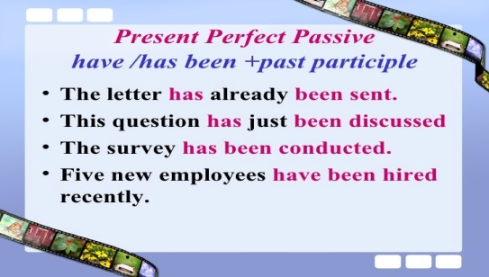  Ex:1 P:77  Tell students that the example sentences are from the listening on page 76.  Ask students to copy the sentences into their notebooks. Put students into pairs to choose the correct options and answer the questions.  Check answers. | Students of the class are listed.  Students' attention is drawn to the lesson.  Determines the topic and purpose of the lesson  Students say different words from the picture  Pupils look at the examples from the listening on page 76. Choose the correct words to complete the rule  ANSWERS  past participle | The teacher to assess learners for their ability.  “Good job!  Well done!”  Formative Assessment  Good job!  Descriptor:  - look at the examples  - choose the correct words  Total: 2 point | Pictures
 | Ex: 2 P: 77  Put students into pairs to complete the exercise. Point out that the agent will sometimes need to be omitted from the sentences that students write. For example, in number 1, the word something is omitted because it conveys information that is obvious and unimportant. Check answers.  Ex: 3 P: 77  Tell students that the example sentences are from the listening on page 76.  Ask students to copy the sentences into their notebooks. Put students into pairs to choose the correct options and complete the rule.  Check answers  Ex: 4 P: 77  Ask students to complete the sentences with the present continuous passive. Use the verbs in brackets.  Put students into pairs to do this exercise.  Check answers. | Pupils rewrite the sentences in the passive.  ANSWERS  2 A lot of new hotels have been built along the coast.  3 The last seat on the plane has just been booked.  4 Has the swimming pool been cleaned yet?  5 That activity holiday has been recommended by a lot of people.  6 Tourism hasn't been encouraged in this part of the country  Pupils look at the examples from the listening on page 76. Choose the correct words to complete the rule.  ANSWERS  1 continuous  2 past participle  Pupils complete the sentences with the present continuous passive. Use the verbs in brackets  ANSWERS  2 are being advised  3 are being cut down  4 's being cleaned  5 is being made  6 is being shown | Descriptor:  - rewrite the sentences in the passive.  Total: 2 point  Descriptor:  - look at the examples  - Choose the correct words to complete the rule  Total: 2 point  Descriptor:  - complete the sentences with the present continuous passive  - use the verbs in brackets  Total: 2 point  -Make CCQ questions Yes / No | Card  Worksheet  Students book
End of the lesson  5 min | FEEDBACK  Learners provide feedback on what they have learned at the lesson.  Ex:  Home task: | Ss evaluate each other and encourage classmate with phrases like:  Well done! Brilliant! Good job! I like it! |  | Poster Success

Short term plan: term 3

Unit 7 Travel and transport |  | Lesson 68
Teacher name:

Date:
Grade: 8 |  | Number present: | absent:
Lesson title | Culture. Like father, like daughter
Learning objectives | 8.3.3.1 give an opinion at discourse level on a wide range of general and curricular topics  8.4.2.1 understand specific information and detail in texts on a growing range of familiar general and curricular topics, including some extended texts;  8.6.14.1 use some prepositions before nouns and adjectives, use prepositions as, like to indicate manner, use dependent prepositions following adjectives on a range of familiar general and curricular topics
Lesson objectives | Learners will be able to:  - watch a video about diff diving in Mexico.  - talk about whether I would like to try cliff diving
Value links | "Creativity and Innovation"  Ability to find optimal ways to solve educational tasks to use new and already familiar algorithms combining, using them in solving non-standard problems
Plan

Stages / Time | Teachers actions | Students actions | Assessment criteria | Resources
Beginning of the lesson  5 min  Middle of the lesson  Presentation part.  35 min | Organization moment :  1.Greeting.  Ask about the weather.  Warming-up  The teacher sets the lesson objectives, letting students know what to anticipate from the lesson.  Revise the language of the previous lesson.  Lead – In    Ex:1 P:78  Ask students to open their books at page 68.  Refer students to the photos and put them into pairs to answer the question.  Do not confirm or reject students' ideas at this point. Students will check their answers in Exercise 2. | Students of the class are listed.  Students' attention is drawn to the lesson.  Determines the topic and purpose of the lesson  Students say different words from the picture  Pupils work with a partner. Look at the photos. Where were they taken? What sport do they show?  ANSWERS  Students own answer | The teacher to assess learners for their ability.  “Good job!  Well done!”  Formative Assessment  Good job!  Descriptor:  - look at the photos  - answer the question  Total: 2 point | Pictures
 | Ex: 2 P: 78  Refer students to the phrases a-c  Tell students they are going to watch the video to first check their answers to Exercise 1 and then decide which of the three phrases best describes the subject matter of the video. Check answers.  Ex: 3 P: 78  Tell students that sentences 1-5 all refer to the video  and that some are true and some false. Put students into pairs and ask them to correct the sentences they think are false.  Play the video for students to check their answers.  Ex: 4 P: 78  Refer students to the incomplete sentences.  Play the video again for students to complete the sentences. You may need to play the video twice to help weaker students.  Students can compare answers in pairs before you check answers. | Pupils watch the video and check your answers to Exercise 1. What is the video about?  ANSWERS  C  Pupils are these sentences true or false? Correct the false sentences. Then watch the video again and check your answers.  ANSWERS  1 F (a man climbing up a cliff)  2 T  3 F (Iris's mother talking about school and education)  4 F (we can't see Iris's mother)  5 T  Pupils watch the video again and complete the sentences  ANSWERS  2 30 metres  3 80 years  4 school  5 nervous and afraid  6 22 metres | Descriptor:  - watch the video  - answer the question  Total: 2 point  Descriptor:  - watch the video  - mark the statements  Total: 2 point  Descriptor:  - watch the video  - complete the sentences  Total: 2 point  -Make CCQ questions Yes / No | Card  Worksheet  Students book
End of the lesson  5 min | FEEDBACK  Learners provide feedback on what they have learned at the lesson.  Ex:  Home task: | Ss evaluate each other and encourage classmate with phrases like:  Well done! Brilliant! Good job! I like it! |  | Poster Success

Short term plan: term 3

Unit 7 Travel and transport |  | Lesson 69
Teacher name:

Date:
Grade: 8 |  | Number present: | absent:
Lesson title | Reading. The low of the land.
Learning objectives | 8.1.8.1 develop intercultural awareness through reading and discussion  8.5.3.1 write with moderate grammatical accuracy on a limited range of familiar general and curricular topics  8.6.13.1 use a growing variety of modal forms for different functions: obligation, necessity, possibility, permission, requests, suggestions, prohibition on a range of familiar general and curricular topics
Lesson objectives | Learners will be able to:  - read an article about laws in different countries.  - learn verb expressions.  - give my opinion about the laws in the article.
Value links | "Creativity and Innovation"  Use of various cognitive tools, knowledge about the world be able to collect (linguistic, reading culture, information, service in the digital environment)
Plan

Stages / Time | Teachers actions | Students actions | Assessment criteria | Resources
Beginning of the lesson  5 min  Middle of the lesson  Presentation part.  35 min | Organization moment :  1.Greeting.  Ask about the weather.  Warming-up  The teacher sets the lesson objectives, letting students know what to anticipate from the lesson.  Revise the language of the previous lesson.  Ex:1 P:79  Ask students to open their books at page 79. Refer students to the photos.  Put students into pairs and ask them to answer the questions. Do not confirm or reject students' ideas at this point. Student will check their answers in Exercise 2.  Ex: 2 P: 79  Ask students to read the travel article to check their answers from Exercise 1. | Students of the class are listed.  Students' attention is drawn to the lesson.  Determines the topic and purpose of the lesson  Students say different words from the picture  Pupils work with a partner. Look at the photos. Answer the question.  ANSWERS  Students own answer  Pupils read the travel article and check your answers  ANSWERS  chewing gum in Singapore; it ruins the city's clean pavements | The teacher to assess learners for their ability.  “Good job!  Well done!”  Formative Assessment  Good job!  Descriptor:  - work with a partner  - answer the question  Total: 2 point  Descriptor:  - read the travel article  - check your answers  Total: 2 point | Pictures
 | Ex: 3 P: 79  Ask students to read the article again and then put them in pairs to match the information in the sentences with Singapore, Venice or Athens.  Check answers. Challenge stronger students when they give their answers to give more information than what is required to answer the question, e.g. in item 1 you would ask what the difference of opinion is about the law in question in Singapore  Ex: 4 P: 79  Refer students to the highlighted words in the article. Ask students to work alone to match the words with the definitions.  Check answers.  Ex: 5 P: 79  Ask students to work alone to complete the sentences.  Students can compare their answers in pairs before you check answers with the class as a whole.  To extend the work on the vocabulary, you could ask students to turn to the Vocabulary bank on page 127 and do the exercises for Explore verb expressions. | feeding the pigeons in St Mark's Square in Venice; the damage done to the ancient monuments wearing high heels to ancient Greek sites; they can do terrible damage to the ancient stones  Pupils read the article again and match the information (1–6) with the places, Singapore, Venice or Athens  ANSWERS  1 Singapore  2 Venice  3 Singapore  4 Athens  5 Venice  6 Athens  Pupils match the highlighted words in the article with the definitions.  ANSWERS  1 come into existence  2 see the point  3 dates back to  4 went ahead  5 take care  6 running out of  Pupils complete the sentences with the correct form of verb expressions from Exercise 4  ANSWERS  1 come into existence  2 running out of  3 dates back to  4 see the point  5 Take care | Descriptor:  - read the article  - match the information with the places  Total: 2 point  Descriptor:  - match the highlighted words  - complete the sentences  Total: 2 point  Descriptor:  - complete the sentences  Total: 2 point  -Make CCQ questions Yes / No | Card  Worksheet  Students book
End of the lesson  5 min | FEEDBACK  Learners provide feedback on what they have learned at the lesson.  Ex:  Home task: | Ss evaluate each other and encourage classmate with phrases like:  Well done! Brilliant! Good job! I like it! |  | Poster Success

Short term plan: term 3

Unit 7 Travel and transport |  | Lesson 70
Teacher name:

Date:
Grade: 8 |  | Number present: | absent:
Lesson title | Speaking Getting more information
Learning objectives | 8.5.6.1 link, independently, sentences into coherent paragraphs using a variety of basic connectors on a range of familiar general topics and some curricular topics  8.6.14.1 use some prepositions before nouns and adjectives  use prepositions as, like to indicate manner  use dependent prepositions following adjectives on a range of familiar general and curricular topics
Lesson objectives | Learners will be able to:  - watch teenagers talking about the biggest mistake they have ever made.  - listen to a teenager talk about a mistake she made.  - practise getting more information from someone
Value links | "Independence and patriotism",  To the past, present and future of the people understand the relevance
Plan

Stages / Time | Teachers actions | Students actions | Assessment criteria | Resources
Beginning of the lesson  5 min | Organization moment :  1.Greeting.  Ask about the weather.  Warming-up  The teacher sets the lesson objectives, letting students know what to anticipate from the lesson.  Revise the language of the previous lesson.  Lead – In  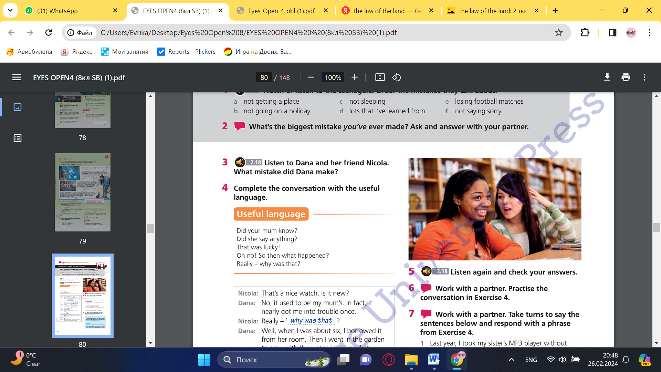  Ex:1 P:80  Ask students to open their books at page 80.  Tell students they are going to watch some teenagers answering the following question:  What's the biggest mistake you've ever made?  Refer students to items a-f. Play the video for students to order the mistakes.  Check answers. Encourage stronger students to give as much detail as they can in their answers. | Students of the class are listed.  Students' attention is drawn to the lesson.  Determines the topic and purpose of the lesson  Students say different words from the picture  Pupils watch or listen to the teenagers. Order the mistakes they talk about.  ANSWERS  1 c  2 e  3 b  4 a  5 f  6 d | The teacher to assess learners for their ability.  “Good job!  Well done!”  Formative Assessment  Good job!  Descriptor:  - watch or listen to the teenagers  - ask and answer the question  Total: 2 point | Pictures
Middle of the lesson  Presentation part.  30 min | Ex: 2 P: 80  Put students into pairs to ask and answer the question. Ask some students to report back to the class on what their partner said  Ex: 3 P: 80  Tell students they are going to listen to Dana talk to her friend Nicola about a mistake.  Read out the question.  Play the recording.  Students listen and answer the question.  Check answer.  Ex: 4 P: 80  Refer students to the phrases in the Useful language box.  Students can either work alone or in pairs to complete the conversation using the phrases in the Useful language box | Pupils what’s the biggest mistake you’ve ever made? Ask and answer with your partner  ANSWERS  Students own answer  Pupils listen to Dana and her friend Nicola.  ANSWERS  She borrowed her mum's watch and lost it in the garden.  Pupils complete the conversation with the useful language  ANSWERS  Students own answer | Descriptor:  - ask and answer the question  Total: 2 point  Descriptor:  - listen to Dana and her friend Nicola.  - answer the question.  Total: 2 point  Descriptor:  - complete the conversation  - use the phrases  Total: 2 point  -Make CCQ questions Yes / No | Card  Worksheet  Students book
End of the lesson  5 min | FEEDBACK  Learners provide feedback on what they have learned at the lesson.  Ex:  Home task: | Ss evaluate each other and encourage classmate with phrases like:  Well done! Brilliant! Good job! I like it! |  | Poster Success

Short term plan: term 3

Unit 7 Travel and transport |  | Lesson 71
Teacher name:

Date:
Grade: 8 |  | Number present: | absent:
Lesson title | Speaking Getting more information
Learning objectives | 8.3.3.1 give an opinion at discourse level on a wide range of general and curricular topics  8.4.2.1 understand specific information and detail in texts on a growing range of familiar general and curricular topics, including some extended texts  8.5.1.1 plan, write, edit and proofread work at text level with little support on a range of general and curricular topics
Lesson objectives | Learners will be able to:  - watch teenagers talking about the biggest mistake they have ever made.  - listen to a teenager talk about a mistake she made.  - practise getting more information from someone
Value links | "Independence and patriotism",  Assessment of the importance of loyalty to the motherland, the history of the country respect culture
Plan

Stages / Time | Teachers actions | Students actions | Assessment criteria | Resources
Beginning of the lesson  5 min  Middle of the lesson  Presentation part.  35 min | Organization moment :  1.Greeting.  Ask about the weather.  Warming-up  The teacher sets the lesson objectives, letting students know what to anticipate from the lesson.  Revise the language of the previous lesson.  Lead – In  Ex: 5 P: 80  Play the recording for students to check their answers | Students of the class are listed.  Students' attention is drawn to the lesson.  Determines the topic and purpose of the lesson  Students say different words from the picture  Pupils listen again and check your answers.  ANSWERS  2 mum know  3 then what happened  4 say anything  5 That was lucky | The teacher to assess learners for their ability.  “Good job!  Well done!”  Formative Assessment  Good job!  Descriptor:  - listen again  - check your answers  Total: 2 point | Pictures
 | Ex: 6 P: 80  Ask students to work in pairs to act out the conversation in Exercise 4.  Students can act out the conversation twice, taking a different part each time  Ex: 7 P: 80  Do the first one as an example with the class. Put students into pairs and ask them to take it in turns to say and respond to sentences 1-6 using the language introduced in Exercise 4.  Ex: 8 P: 80  Read out the instructions and make sure that students understand what they have to do.  Give students some time to plan what they want to say.  Students then act out their conversations.  Monitor while students are practising their conversations. Check that they are using the phrases from the Useful language box. | Pupils work with a partner. Practise the conversation in Exercise 4.  ANSWERS  Students own answer  Pupils work with a partner. Take turns to say the sentences below and respond with a phrase from Exercise 4  ANSWERS  Students own answer  Pupils work with a partner. Plan your own conversation. Use the ideas below and Exercise 4 to help you.  ANSWERS  Students own answer | Descriptor:  - work with a partner  - practise the conversation  Total: 2 point  Descriptor:  - work with a partner.  - respond to sentences using the language  Total: 2 point  Descriptor:  - work with a partner.  - use the ideas  Total: 2 point  -Make CCQ questions Yes / No | Card  Worksheet  Students book
End of the lesson  5 min | FEEDBACK  Learners provide feedback on what they have learned at the lesson.  Ex:  Home task: | Ss evaluate each other and encourage classmate with phrases like:  Well done! Brilliant! Good job! I like it! |  | Poster Success

Short term plan: term 3

Unit 7 Travel and transport |  | Lesson 72
Teacher name:

Date:
Grade: 8 |  | Number present: | absent:
Lesson title | Writing Telling a story
Learning objectives | 8.2.4.1 understand with little or no support most of the implied meaning in extended talk on a range of general and curricular topics;  8.4.5.1 deduce meaning from context in short texts and some extended texts on a growing range of familiar general and curricular topics;
Lesson objectives | Learners will be able to:  - read an email about an accident.  - learn about the use of adverbs.  - write a story about an event in my life.
Value links | "Independence and patriotism"  Respect the state symbols of Kazakhstan, understand the meaning of public holidays
Plan

Stages / Time | Teachers actions | Students actions | Assessment criteria | Resources
Beginning of the lesson  5 min  Middle of the lesson  Presentation part.  35 min | Organization moment :  1.Greeting.  Ask about the weather.  Warming-up  The teacher sets the lesson objectives, letting students know what to anticipate from the lesson.  Revise the language of the previous lesson.  Lead – In  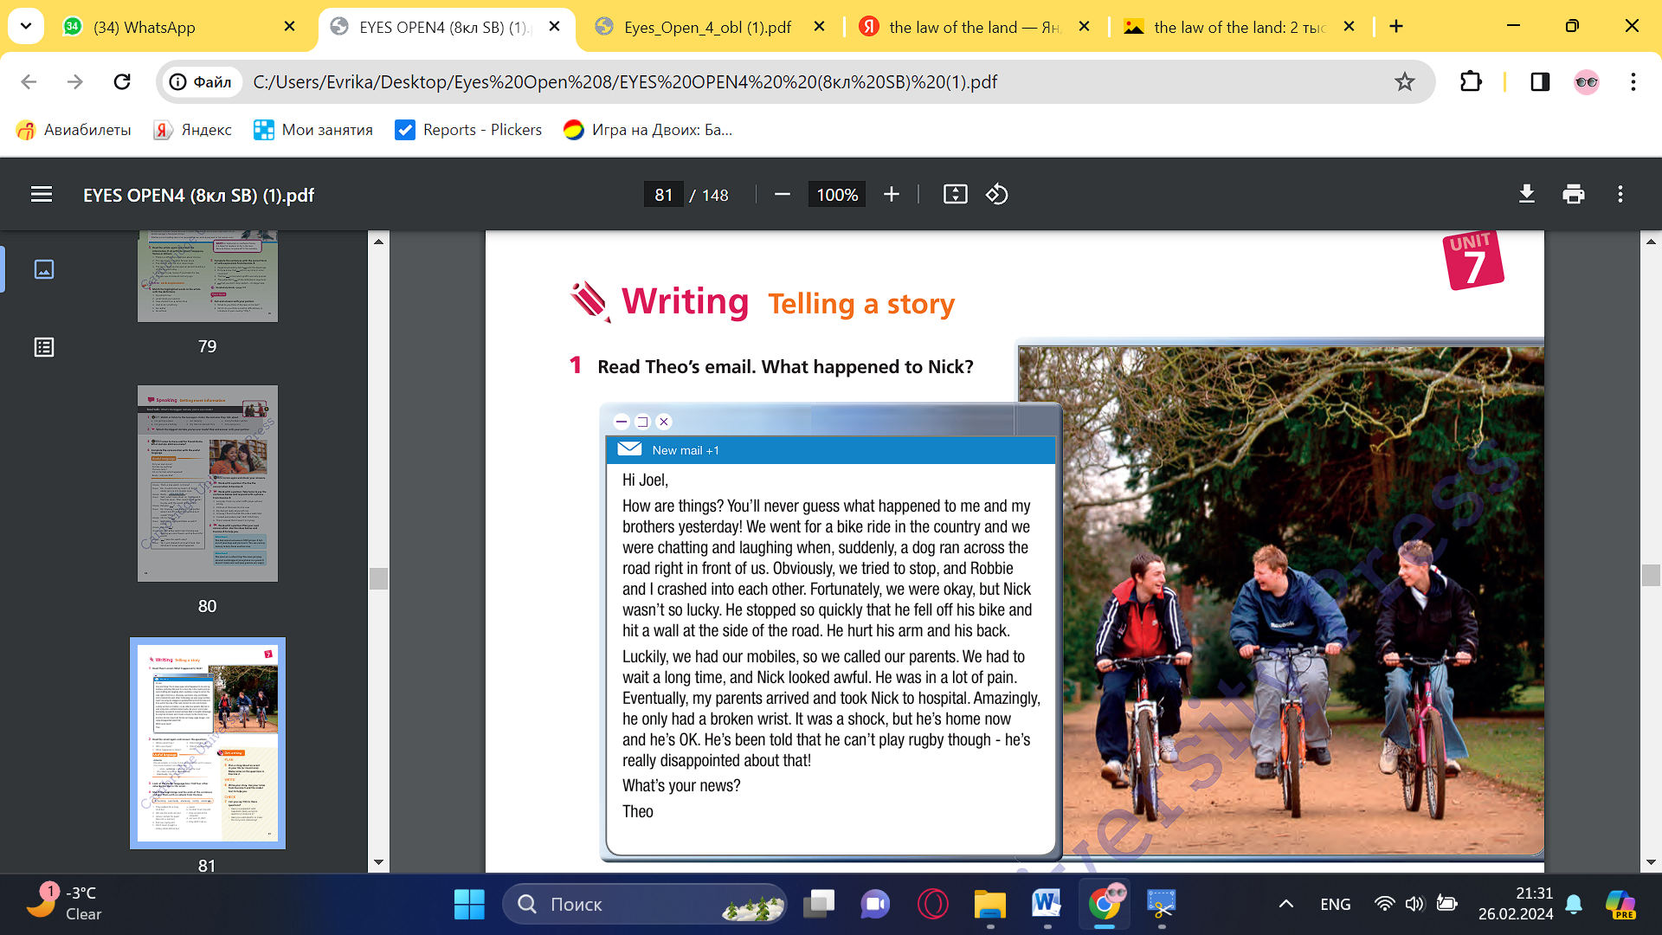  Ex: 1 P: 81  Ask students to open their books at page 81.  Refer students to the photo and then ask them to guess the story related in Theo's email.  Ask students to read the email and then answer the question.  Check answer. | Students of the class are listed.  Students' attention is drawn to the lesson.  Determines the topic and purpose of the lesson  Students say different words from the picture  Pupils read Theo’s email. What happened to Nick?  ANSWERS  Nick fell off his bike and hit a wall at the side of the road. He hurt his arm and his back. He broke his wrist. | The teacher to assess learners for their ability.  “Good job!  Well done!”  Formative Assessment  Good job!  Descriptor:  - read Theo’s email.  - aanswer the question  Total: 2 point | Pictures
 | You could then point out that the phrase you'll never guess, which is seen at the beginning of the second sentence in the email, is commonly used when introducing information that the speaker expects will be greeted with surprise, e.g. You'll never guess what happened to me today: I won £5,000 in the lottery!  Ex: 2 P: 81  Refer students to the five questions.  Ask students to read the email again.  Students can then work alone to answer the questions.  Check answers.  Ex: 3 P: 81  Read out the information about how adverbs are used in the Useful language box.  Ask students to work alone to find further examples of adverbs used by Theo in the email in Exercise 1.  Check answers.  Ex: 4 P: 81  Put students into pairs and ask them to match the beginnings and ends of the sentences by joining them with the adverbs from the box.  Check answers. | Pupils read the email again and answer the questions  ANSWERS  1 in the country  2 Theo and his brothers (Robbie and Nick)  3 While they were cycling, a dog ran across the road right in front of them. Theo and Robbie crashed into each other. Nick fell off his bike.  4 They called their parents.  5 Their parents arrived and took Nick to hospital  Pupils look at the Useful language box. Find four other adverbs like this in the email.  ANSWERS  Obviously, we tried to stop,  Fortunately, we were okay,  Luckily, we had our mobiles,  Amazingly, he only had a broken wrist.  Pupils match the beginnings and the ends of the sentences and join them with an adverb from the box.  ANSWERS  1 c They walked for a long time but eventually they arrived at the campsite.  2 e We saw the wild cats but fortunately they didn't see us.  3 b James crashed his quad bike into a tree but amazingly he didn't hurt himself.  4 a She was crying and obviously upset.  5 d We'd never bought a lottery ticket before but luckily we won £1,000! | Descriptor:  - read the email  - answer the questions  Total: 2 point  Descriptor:  - look at the Useful language box  - find four other adverbs  Total: 2 point  Descriptor:  - match the beginnings  - join them with an adverb  Total: 2 point  -Make CCQ questions Yes / No | Card  Worksheet  Students book
End of the lesson  5 min | FEEDBACK  Learners provide feedback on what they have learned at the lesson.  Ex:  Home task: | Ss evaluate each other and encourage classmate with phrases like:  Well done! Brilliant! Good job! I like it! |  | Poster Success

Short term plan: term 3

Unit 7 Travel and transport |  | Lesson 73
Teacher name:

Date:
Grade: 8 |  | Number present: | absent:
Lesson title | CLIL: Technology Passive houses  Summative assessment for the unit 7
Learning objectives | 8.2.2.1 understand with little or no support most specific information in extended talk on a wide range of general and curricular topics  8.4.2.1 understand specific information and detail in texts on a growing range of familiar general and curricular topics, including some extended texts;  8.6.5.1 use questions which include a variety of different tense and modal forms on a range of familiar general and curricular topics;
Lesson objectives | Learners will be able to:  - learn about passive houses.  - talk about different types of houses
Value links | "Independence and patriotism",  To the past, present and future of the people understand the relevance
Plan

Stages / Time | Teachers actions | Students actions | Assessment criteria | Resources
Beginning of the lesson  3 min  Middle of the lesson  Presentation part.  35 min | Organization moment :  1.Greeting.  Ask about the weather.  Warming-up  The teacher sets the lesson objectives, letting students know what to anticipate from the lesson.  Revise the language of the previous lesson.  Lead – In  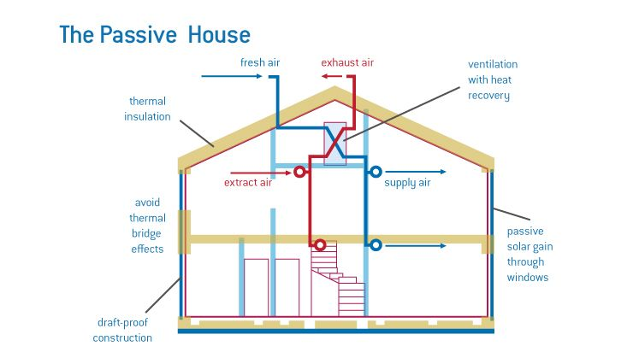  Ex: 1 P: 82  Ask students to open their books at page 82. Put students into pairs to ask and answer the questions | Students of the class are listed.  Students' attention is drawn to the lesson.  Determines the topic and purpose of the lesson  Students say different words from the picture  Pupils work with a partner and answer the questions  ANSWERS  Students own answer | The teacher to assess learners for their ability.  “Good job!  Well done!”  Formative Assessment  Good job!  Descriptor:  - work with a partner  - answer the question  Total: 2 point | Pictures
 | Ex: 2 P: 82  Ask students to read the article about passive houses.  Check answer.  Put students into pairs to answer the question.  Ex: 3 P: 82  Refer students to the diagram.  Put students into pairs and ask them to label the diagram.  Check answers  Ex: 4 P: 82  Tell students they are going to listen to a conversation between two friends.  Read out the question.  Play the recording.  Check answer  Ex: 5 P: 82  Refer students to the table, which shows the differences between the two houses described in the recording.  Play the recording again.  Ask students to work in pairs to complete the table.  Check answers. | Pupils read the article about passive houses. Are they designed for hot climates, cold climates or both?  ANSWERS  They are designed for both climates.  Pupils complete the diagram of a passive house with the words in the box  ANSWERS  a summer sun  b low roof  c winter sun  d thick walls  e good quality windows  Pupils listen to two friends talking about their holidays. Which house sounds more comfortable to stay in?  ANSWERS  The passive house sounds more comfortable  Pupils listen again and copy and complete the table.  ANSWERS  1 sun  2 cold  3 big  4 bright, sunny  5 a lot | Descriptor:  - read the article  - answer the question  Total: 2 point  Descriptor:  - complete the diagram  - label the diagram  Total: 2 point  Descriptor:  - listen to two friends  - answer the question  Total: 2 point  -Make CCQ questions Yes / No | Card  Worksheet  Students book
End of the lesson  5 min | FEEDBACK  Learners provide feedback on what they have learned at the lesson.  Ex:  Home task: | Ss evaluate each other and encourage classmate with phrases like:  Well done! Brilliant! Good job! I like it! |  | Poster Success

Short term plan: term 3

Unit 7 Travel and transport |  | Lesson 74
Teacher name:

Date:
Grade: 8 |  | Number present: | absent:
Lesson title | Extra reading: Destination Kazakhstan
Learning objectives | 8.2.2.1 understand with little or no support most specific information in extended talk on a wide range of general and curricular topics  8.4.2.1 understand specific information and detail in texts on a growing range of familiar general and curricular topics, including some extended texts;  8.5.3.1 write with moderate grammatical accuracy on a limited range of familiar general and curricular topics
Lesson objectives | Learners will be able to:  - read a text about tourist activities near Almaty.  - answer comprehension questions about the text.  - write an email recommending tourist activities in my area
Value links | "Independence and patriotism"  Respect the state symbols of Kazakhstan, understand the meaning of public holidays
Plan

Stages / Time | Teachers actions | Students actions | Assessment criteria | Resources
Beginning of the lesson  5 min  Middle of the lesson  Presentation part.  35 min | Organization moment :  1.Greeting.  Ask about the weather.  Warming-up  The teacher sets the lesson objectives, letting students know what to anticipate from the lesson.  Revise the language of the previous lesson.  Lead – In  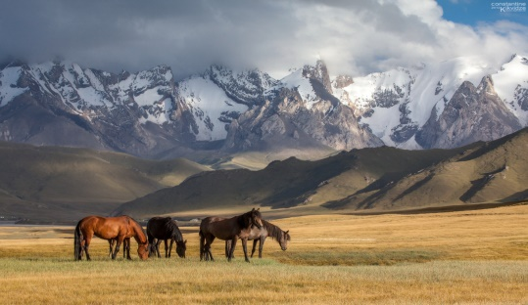  Ex: 1 P: 83  Ask students to read the text once and check if any of their ideas are mentioned in the text.  Then read out the questions and invite students to raise their hand if they have visited a national park. Put students in pairs or groups so there's at least one student who has visited a national park. | Students of the class are listed.  Students' attention is drawn to the lesson.  Determines the topic and purpose of the lesson  Students say different words from the picture  Pupils answer the question. Have you ever visited one of Kazakhstan’s national parks? What did you do there?  ANSWERS  Students own answer | The teacher to assess learners for their ability.  “Good job!  Well done!”  Formative Assessment  Good job!  Descriptor:  - read the text  - answer the question  Total: 2 point | Pictures
 | Students spend a few minutes discussing their experiences. If students haven't been to a national park, encourage them to ask questions to their partner(s) who has. They can also say which national park they'd like to visit and why. Help weaker students by pointing out that they should use present perfect simple to answer the first question (e.g. I've been to Altyn Emel National Park.) and then give details using the past simple (e.g. We saw / went / skied...) Invite individual students to report on what their pair or group discussed  .  Ex: 2 P: 83  • Ask students to read the text again and answer the questions. Tell them to also read the information in the About the Aktau Mountains.  Students can compare answers in pairs before you check them with the class.  Invite individual students to report on what their pair or group discussed  Ex: 3 P: 83  Students work in pairs to discuss which of the places from the text they'd prefer as a holiday destination. Remind students to give reasons using evidence from the text and personal opinions | Pupils read the text, then answer the questions.  ANSWERS  1 It takes three hours.  2 How big Altyn Emel is: 4600km².  3 They are famous for their coloured stripes, the 'singing dune' and for the plant and animal fossils that have been found there.  4 It's 25km from Almaty.  5 26 different countries.  6 It was the year when Prince Harry went skiing at Shymbulak with his girlfriend.  Pupils would you prefer to go to Altyn Emel or Shymbulak on holiday? Tell a partner and explain why  ANSWERS  Students own answer | Descriptor:  - read the text  - answer the question  Total: 2 point  Descriptor:  - read the text  - answer the questions  Total: 2 point  -Make CCQ questions Yes / No | Card  Worksheet  Students book
End of the lesson  5 min | FEEDBACK  Learners provide feedback on what they have learned at the lesson.  Ex:  Home task: | Ss evaluate each other and encourage classmate with phrases like:  Well done! Brilliant! Good job! I like it! |  | Poster Success

Short term plan: term 3

Unit 7 Travel and transport |  | Lesson 75
Teacher name:

Date:
Grade: 8 |  | Number present: | absent:
Lesson title | 6-7 Review
Learning objectives | 8.3.7.1 use appropriate subject-specific vocabulary and syntax to talk about a range of general topics, and some curricular topics  8.4.5.1 deduce meaning from context in short texts and some extended texts on a growing range of familiar general and curricular topics;
Lesson objectives | Learners will be able to:  - use vocabulary for the elements of a story.  - use vocabulary for travel and transport
Value links | "Independence and patriotism",  To the past, present and future of the people understand the relevance
Plan

Stages / Time | Teachers actions | Students actions | Assessment criteria | Resources
Beginning of the lesson  3 min | Organization moment :  1.Greeting.  Ask about the weather.  Warming-up  The teacher sets the lesson objectives, letting students know what to anticipate from the lesson.  Revise the language of the previous lesson.  Lead – In    Ex: 1 P: 84  Explain the task and give Ss time to complete it. Join the beginnings (1–8) with the endings (a–h) to make sentences. Then check Ss' answers around the class | Students of the class are listed.  Students' attention is drawn to the lesson.  Determines the topic and purpose of the lesson  Students say different words from the picture  Pupils join the beginnings with the endings  ANSWERS  2 a  3 g  4 f  5 b  6 c  7 h  8 e | The teacher to assess learners for their ability.  “Good job!  Well done!”  Formative Assessment  Good job!  Descriptor:  - join the beginnings  - make sentences  Total: 2 point | Pictures
Middle of the lesson  Presentation part.  30 min | Ex: 2 P: 84  Ask students to choose the correct words to complete the sentences.  Check answer.  Put students into pairs to answer the question.  Ex: 3 P: 84  Explain the task and give Ss time to complete it. Write the words and phrases in the box by the correct definition. Then check Ss' answers around the class.  Ex: 4 P: 84  Ask students to complete the adjective with the correct ending (-ed or -ing).  Check answer.  Put students into pairs to answer the question.  Ex: 5 P: 84  Ask students to work in pairs to complete the missing text with the words in the box.  Check answers. | Pupils choose the correct words to complete the sentences.  ANSWERS  2 In order to  3 so that  4 Of course,  5 Rather than  6 then again,  Pupils write the words and phrases in the box by the correct definition.  ANSWERS  2 travel by rail  3 go abroad  4 see the sights  5 arrive at your destination  6 reserve a seat  7 go backpacking  8 hire a car  Pupils complete the adjective with the correct ending (-ed or -ing).  ANSWERS  2 ed  3 -ing  4 -ing  5 -ed  6 -ing  Pupils complete the missing text with the words in the box.  ANSWERS  1 with  2 and  3 in  4 that  5 by  6 in  7 selling  8 with | Descriptor:  - choose the correct words  - complete the sentences  Total: 2 point  Descriptor:  - write the words and phrases  - complete the sentences  Total: 2 point  Descriptor:  - complete the adjective with the correct ending  Total: 2 point  Descriptor:  - work in pairs  - complete the missing text  Total: 2 point  -Make CCQ questions Yes / No | Card  Worksheet  Students book
End of the lesson  5 min | FEEDBACK  Learners provide feedback on what they have learned at the lesson.  Ex:  Home task: | Ss evaluate each other and encourage classmate with phrases like:  Well done! Brilliant! Good job! I like it! |  | Poster Success

Short term plan: term 3

Unit 7 Travel and transport |  | Lesson 76
Teacher name:

Date:
Grade: 8 |  | Number present: | absent:
Lesson title | Language focus
Learning objectives | 8.4.5.1 deduce meaning from context in short texts and some extended texts on a growing range of familiar general and curricular topics;  8.5.3.1 write with moderate grammatical accuracy on a limited range of familiar general and curricular topics
Lesson objectives | Learners will be able to:  - learn reported statements.  -talk about holiday destinations
Value links | "Independence and patriotism"  Respect the state symbols of Kazakhstan, understand the meaning of public holidays
Plan

Stages / Time | Teachers actions | Students actions | Assessment criteria | Resources
Beginning of the lesson  5 min | Organization moment :  1.Greeting.  Ask about the weather.  Warming-up  The teacher sets the lesson objectives, letting students know what to anticipate from the lesson.  Revise the language of the previous lesson.  Lead – In  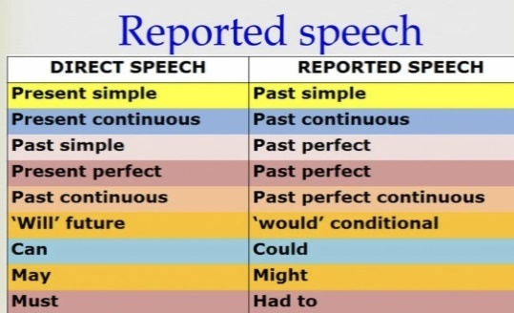  Ex: 1 P: 85  Explain the task and give Ss time to complete it.Complete the reported statements. Then check Ss' answers around the class. | Students of the class are listed.  Students' attention is drawn to the lesson.  Determines the topic and purpose of the lesson  Students say different words from the picture  Pupils complete the reported statements  ANSWERS  2 She said she had never seen one before.  3 He told them he could see the top of the mountain.  4 They told him they had really enjoyed the trip.  5 They said they would tell all their friends about it. | The teacher to assess learners for their ability.  “Good job!  Well done!”  Formative Assessment  Good job!  Descriptor:  - complete the reported statements  Total: 2 point | Pictures
Middle of the lesson  Presentation part.  30 min | Ex: 2 P: 85  Ask students to put the words in order to make reported questions, requests or commands.  Check answer.  Put students into pairs to answer the question.  Ex: 3 P: 85  Explain the task and give Ss time to complete it. Complete the text using the correct passive form of the verbs in brackets. Record recycling competition. Then check Ss' answers around the class. | Pupils put the words in order to make reported questions, requests or commands.  ANSWERS  1 She asked him where he was from.  2 He asked us when we had arrived.  3 He asked them if they were on holiday.  4 I asked you not to take photographs here.  5 He told her to be careful.  Pupils complete the text using the correct passive form of the verbs in brackets. Record recycling competition  ANSWERS  2 were replaced  3 are not used  4 were thrown  5 can be recycled  6 will be awarded  7 will be given | Descriptor:  - put the words in order  - make reported questions,  Total: 2 point  Descriptor:  - complete the text  - record recycling competition  Total: 2 point  -Make CCQ questions Yes / No | Card  Worksheet  Students book
End of the lesson  5 min | FEEDBACK  Learners provide feedback on what they have learned at the lesson.  Ex:  Home task: | Ss evaluate each other and encourage classmate with phrases like:  Well done! Brilliant! Good job! I like it! |  | Poster Success

Short term plan: term 3

Unit 7 Travel and transport |  | Lesson 77

Teacher name:

Date:
Grade: 8 |  | Number present: | absent:
Lesson title | Summative Assessment for term 3
Learning objectives | 8.1.8.1 develop intercultural awareness through reading and discussion  8.3.7.1 use appropriate subject-specific vocabulary and syntax to talk about a range of general topics, and some curricular topics  8.6.14.1 use some prepositions before nouns and adjectives  use prepositions as, like to indicate manner  use dependent prepositions following adjectives on a range of familiar general and curricular topics
Lesson objectives | Learners will be able to:
Value links | "Independence and patriotism"  Respect the state symbols of Kazakhstan, understand the meaning of public holidays
Plan

Stages / Time | Teachers’ actions | Students’ actions | Assessment criteria | Resources
Beginning of the lesson  5 min | Organization moment  1.Greeting.  Ask about the weather.  The teacher sets the lesson objectives, letting students know what to anticipate from the lesson.  Warm-up  Fasten your seat belts and get ready for the all-round race  Lead – In  • With books closed, ask students to recall the previous lesson (Speaking, page 86) and elicit what they remember about the scenario.  • Ask: Where was the woman? (In a shop.) What was she doing? (Returning a record.) What did she want? (To change it.) Did she get what she wanted? | Students' attention is drawn to the lesson.  Students discuss the pictures in pairs.  Determines the topic and aim of the lesson  Students say different words from the picture | Formative Assessment  Good job!  Assessment criteria  -Identify detailed information in extended conversation with support | Pictures  Student’s book
Middle of the lesson  Presentation part.  35 min | LISTENING  Task. Listen to five people talking about different celebrations. Match the halves of the sentences (1-4) with the opinions (A-F) to make true sentences. ONE argument is extra. CD3 Tapescript3  Task. Choose and circle the correct answer A, B or C  READING  Task. Paraphrase the given sentences so it has similar meaning. Use the given beginnings of sentences. Example, No kitchen was needed to prepare popcorn. Preparation _________________________. Answer, Preparation of popcorn did not need any kitchen  Task. Answer the questions.  5. Why have cinemas sold popcorn since the 19th century?  6. Why cannot popcorn be dissapperead from cinemas?  WRITING  Choose ONE of the topics and write.  Topic 1. You are a blogger who shares with own experience. Write a story about a concert you have been to. Include the following information in your review:.  The concert; when? / where?  The band: people in the band/ kind of music/ songs played The audience: how many people / their reaction  Problems: the music/ the sound quality/ the time  Suggestions: different place / different time / different kind of music  SPEAKING  Task. You are given questions to speak about for 2-3 minutes. Before you speak you have one minute to think about what you are going to say. | Students Listen to five people talking about different celebrations then match  Descriptor:  - listen and match  Differentiation:  «Verbal support» method is used to help Students use new words in the text.  Students  Descriptor:  - Paraphrase the given sentences so it has similar meaning  Differentiation by support  Less motivated learners will be given prompts to find the correct location of the text() paragraphs  Students choose ONE of the topics and write.  Descriptor:  - Write a story about a concert  Differentiation by support  Less motivated learners will be given prompts to find the correct location of the text() paragraphs | -can match the halves of the sentences  Total: 1 point  -can paraphrase the given sentences  Total: 1 point  -can write a story about a concert  Total: 1 point | Cards  Worksheets
End of the lesson  5 min | FEEDBACK  Learners provide feedback on what they have learned at the lesson. | Ss evaluate each other and encourage classmate with phrases like:  Well done! Brilliant! Good job! I like it! | Students evaluate each other and encourage classmate with phrases like: | Poster

Short term plan: term 3

Unit 7 Travel and transport |  | Lesson 78
Teacher name:

Date:
Grade: 8 |  | Number present: | absent:
Lesson title | Language focus
Learning objectives | 8.3.8.1 recount some extended stories and events on a range of general and curricular topics  8.4.4.1 read a growing range of extended fiction and non-fiction texts on familiar and some unfamiliar general and curricular topics
Lesson objectives | Learners will be able to:  - learn reported statements.  -talk about holiday destinations
Value links | "Independence and patriotism"  Respect the state symbols of Kazakhstan, understand the meaning of public holidays
Plan

Stages / Time | Teachers actions | Students actions | Assessment criteria | Resources
Beginning of the lesson  5 min  Middle of the lesson  Presentation part.  35 min | Organization moment :  1.Greeting.  Ask about the weather.  Warming-up  The teacher sets the lesson objectives, letting students know what to anticipate from the lesson.  Revise the language of the previous lesson.  Lead – In  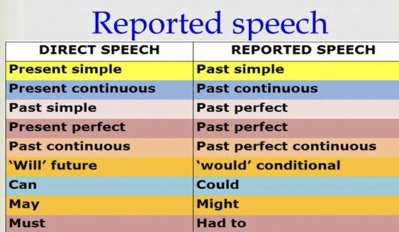  Ex: 4 P: 85  Ask students to rewrite the sentences in the passive..  Check answer.  Put students into pairs to answer the question. | Students of the class are listed.  Students' attention is drawn to the lesson.  Determines the topic and purpose of the lesson  Students say different words from the picture  Pupils rewrite the sentences in the passive.  ANSWERS  1 A new hotel is being built.  2 My bike has been stolen.  3 A great film is being shown at the cinema this week.  4 We have been told to bring a picnic.  5 The children are being taught to swim. | The teacher to assess learners for their ability.  “Good job!  Well done!”  Formative Assessment  Good job!  Descriptor:  - rewrite the sentences  -complete the sentences  Total: 2 point | Pictures
 | Ex: 5 P: 85  Ask students to work in pairs to choose the correct words to complete the text.  Check answers. | Pupils choose the correct words to complete the text.  ANSWERS  2 would  3 been  4 are given  5 to tell  6 if I wanted  7 could  8 where  9 had never been  10 is being built  11 will be  12 invited | Descriptor:  - choose the correct words  - complete the text  Total: 2 point  -Make CCQ questions Yes / No | Card  Worksheet  Students book
End of the lesson  5 min | FEEDBACK  Learners provide feedback on what they have learned at the lesson.  Ex:  Home task: | Ss evaluate each other and encourage classmate with phrases like:  Well done! Brilliant! Good job! I like it! |  | Poster Success

